|  |  |  |  |  |  |
| --- | --- | --- | --- | --- | --- |
| **SCIT**  **School of Computing and Information Technology**  **Faculty of Engineering & Information Sciences** | | | | | |
| **CSIT 321 - Project** | | | |  |
| **Project Topic:** | | | Analyzing and Modelling Weather Patterns | | |
| **Topic Code:** | | | CSIT-20-S2-14 | | |
|  | | | |  |
|  | | | |  |
| **Project Final Report** | | | | | |
|  | | | | | |
| **Group:** | **FYP-20-S2-06** | | | | |
|  |  | | | | |
| |  | | --- | | Ong Choun Kiat | | Elvis Teo Kar Lin | | Yeo Chin Leong | | Koo Shu Min | | | |  | | --- | | 6355055 | | 5655705 | | 6212463 | | 6275989 | | | |  | | --- | | ckong009@mymail.sim.edu.sg | | eklteo001@mymail.sim.edu.sg | | clyeo005@mymail.sim.edu.sg | | smkoo001@mymail.sim.edu.sg | |
| Supervisor: | | Mr Yeo Sze Wee Aaron | |  |
| Assessor: | | Mr Japit Sionggo | |  |

**Table of Contents**

***Introduction*** ***4***

***Project Objective*** ***4***

***Project Scope*** ***4***

***Target Audience*** ***4***

***Stakeholders*** ***4***

***Project Charter*** ***5***

***Requirements Specification Documentation*** ***8***

***Functional Requirements (listed by priority)*** ***8***

***Non-functional Requirements*** ***9***

***Use Case Diagram (User)*** ***10***

***Use Case Diagram (Meteorologist)*** ***11***

***Use Case Description (User)*** ***12***

***Use Case Description (Meteorologist)*** ***22***

***Systems Design Documentation*** ***27***

***Development Methodology*** ***27***

***Implementation and Testing*** ***29***

***Metric to choose the best model*** ***29***

***Comparison between ARIMA and Prophet Model*** ***30***

***User Interface*** ***53***

***Activity Diagram*** ***57***

***Sequence Diagram*** ***58***

***Testing Plan*** ***59***

***Introduction*** ***59***

***Scope*** ***59***

***Approach*** ***59***

***Function Tab Units*** ***59***

***Test Schedule, Roles and Responsibilities*** ***60***

***Individual Function Tab Units Test Cases*** ***61***

***Test risk and Mitigation / Contingency*** ***86***

***Risk Management Strategies*** ***87***

***Problems Encountered with Resolutions*** ***87***

***Issues and Risks Review*** ***93***

***Appendix*** ***94***

***Project Progress Report*** ***95***

***Summary*** ***95***

***Milestones*** ***95***

***Milestone Completion Review*** ***97***

***Roles and Responsibility*** ***99***

***Project Website Link*** ***99***

***Project Schedule*** ***100***

***User Manual*** ***103***

***Introduction:*** ***103***

***For User:*** ***103***

***For Meteorologists:*** ***107***

***Meeting Minutes*** ***108***

# Introduction

## Project Objective

To create an essential and comprehensive system for the human body residing or visiting Singapore in which models and analyzes Weather Patterns where individuals would be able to view the forecast via the Weather Pattern Modelling system to understand and plan the day with convenience as one is able to comprehensively plan and adjust the desired schedules or events in accordance to the Forecast without any hassle or interference. At the same time, these weather patterns can be artificially generated in random based on a set of parameters that can be modified, or obtained from sources like climate centres and based on the weather model, the platform should be able to predict weather and weather events which would allow meteorologist to fully analyse and cultivate the datasets provided in order to carefully carry out crucial and important researches

## Project Scope

The scope of the project should include substantial requirements such as gathering and analysis, project proposal, data gathering, data cleaning, data analysis, predicting, technical design, coding, testing and demonstration and the development of a comprehensive Weather Pattern Modelling System allows a brand new horizon of visualization on the weathering patterns and trends. Vast information available on the platform would allow data tracking to efficiently and effectively be carried out as all processes will be done in a single platform, which in turn proves to be an effortless way to monitor the influx of weather patterns and trends.

## Target Audience

**Meteorologist/scientist and anyone who wants to find out about the current/past weather information.**

Our program can be used on a daily basis by users who wish to understand about current, past and even future weather forecast information to aid any form of planning or preparation for any given day. Additionally, the programme also provides functions for weather scientists/meteorologists to input personal datasets to train the system and obtain a generated prediction based on these datasets.

## Stakeholders

1. User
2. Administrator (Meteorologists)

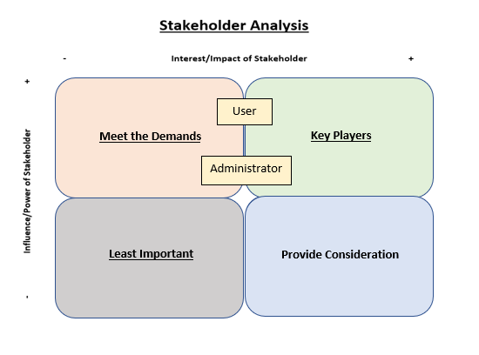

## Project Charter

|  |
| --- |
| ***Key Schedule Milestones:*** |
| Prototype model for the Weather Pattern Modelling System to be incorporated  and completed by 20th June 2020  Launch and initialization of the final and endorsed Weather Pattern Modelling  System by 15th August 2020 |
| ***Main Project Success Criteria:*** |
| To successfully develop and deliver a functional and competent Weather Pattern  Modelling System, which must adhere to all the specifications with detailed  documentation that includes the mentioned scope, designated timeframe and  budget for any User’s usage. |
| ***Approach:*** |
| * A weekly meeting between the project team will be held to concur the weekly progress review. * Clear distinct distribution of workload between the team is required as team members are currently not able to meet up due to the ongoing pandemic which legally binds each member to their respective homes. * Establish clear and pristine communication with regards to the details of the project on which should be prioritised. Completed tasks to be asterisked to assist a distinct understanding between the team. * Conduct researches and studies pertaining to a Weather Pattern Modelling System to further comprehend the operations and utilise the studies as a model for the impending system creation. * Assertive and intricate software testing to be concluded as soon as the Prototype Model is functional. * Within the time frame of 30 working days, development of the following should be completed to help develop the Weather Pattern Modelling System:   + User Stories   + Use Case Diagram   + Use Case Description   + Scope Statement   + Work Break Down Structure   + Gantt Chart   + Risk Register   + Stakeholder List   + Literature Review   + Progress Report   + Minutes Meeting Report * Upon completion of the developmentation mentioned above, Within the allocated time frame of the project, development of the following should be completed:   + Updated Progress Report   + Updated Risk Register   + Test Plan   + Test Cases   + Unit Testing   + Unit Integration   + Unit Maintenance   + Finalised Product |

# 

# Requirements Specification Documentation

Following are the main functions that the tool provides:

1. View current, next and past week’s weather forecast information.
2. View current, next and past month’s weather forecast information.
3. View past years’ weather data.
4. View average of a period of time (week, month, year).
5. Search for specific values
6. View graphs of mean values of specific years.
7. View weather forecast filtered by factors.
8. Insert data files for prediction.
9. Delete unwanted year’s dataset from input.

## Functional Requirements (listed by priority)

|  |  |
| --- | --- |
| **Functional requirement no.** | **Functional requirement description** |
| 1 | Program must be able to run a model/algorithm and forecast future values that are as close as possible to the actual value |
| 2 | Users should be able to run the model/algorithm from the user interface |
| 3 | The User interface must be able to display the results of the forecasted values |
| 4 | Program must be able to change values in dataset into suitable format for model input |
| 5 | Users should be able to insert dataset into the user interface |
| 6 | The results of the forecasted values should be filterable |
| 7 | Program must be able to fill in missing values in dataset |
| 8 | Program must be able to display graphs from the dataset |
| 9 | Program must be able to format different data types |

## 

## Non-functional Requirements

|  |  |
| --- | --- |
| **Non-Functional requirement no.** | **Non-Functional requirement description** |
| 1 | The response time of the program should not take more than 5 seconds |
| 2 | The response time of the user interface should not take more than 5 seconds |
| 3 | The program should be scalable to take in large datasets |
| 4 | The user interface of the program should be easy to use for the user |
| 5 | The code written should be easily readable |

## 

## Use Case Diagram (User)

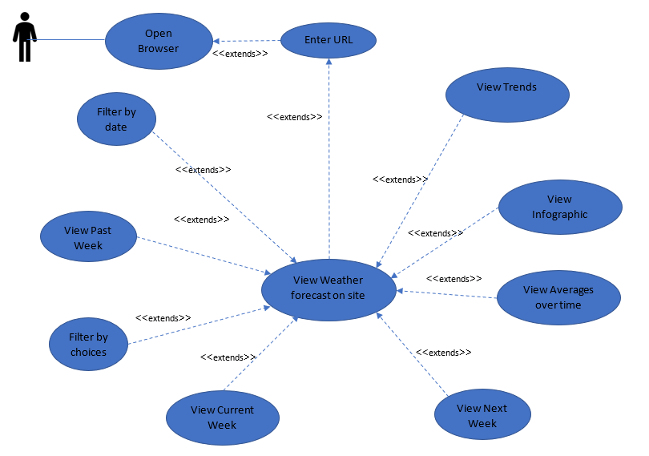

## Use Case Diagram (Meteorologist)

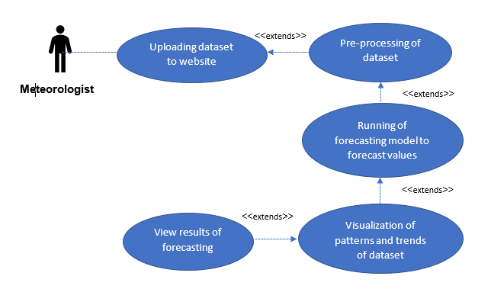

## Use Case Description (User)

1) As a user, I would like to check on the weather forecast online so that I would be able to understand and prepare myself for the duration that I would be there for. The fields required are the temperature, weather, timeslots, humidity and season.

|  |  |
| --- | --- |
| **Name: Open Browser to Search for Forecast (User)** | **ID: 1** |
| **Description:** User wants to open the browser to search for what the Weather Forecast might be. | |
| **Actors:** User | |
| **Pre-Condition:**   1. User wants to initiate the launch of Browser. | |
| **Trigger:** User wants to use the services that have been made available. | |
| **Normal Flow:**   1. User launches the browser to initialize the start-up. 2. User enters stipulated weblink in the respective field. 3. Browser will authenticate the web link by verifying it against the database. 4. End. | |
| **Post-Condition:** User is directed to the stipulated website. | |
| **Sub-Flow:** NIL | |
| **Alternate/Exceptional Flows:** NIL | |

2)As a user, I would like to understand and know how the weather displayed is being analyzed. The analysis should contain data such as past temperature, weather, timeslots, humidity and season.

|  |  |
| --- | --- |
| **Name: View Site for Weather Forecast (User)** | **ID: 2** |
| **Description:** User views Weather Forecast to find out what the weather is today | |
| **Actors:** User | |
| **Pre-Condition:**   1. User enters stipulated weblink to successfully view the Weather Forecast for the day. | |
| **Trigger:** User wants to understand what the weather forecast might be for the day. | |
| **Normal Flow:**   1. Browser redirect User to stipulated weblink. 2. Website displays the weather forecast 3. User clicks on buttons/tabs to see between weather information 4. End. | |
| **Post-Condition:** A weather forecast will be displayed upon detection of a new visit to the website. | |
| **Sub-Flow:** NIL | |
| **Alternate/Exceptional Flows:** NIL | |

3)As a user, I want to be able to view information about the specific day on a website, so that I would be able to better equip and prepare myself for the programs that had been planned.

4)As a user, I want to be able to view predictions for the next day, so that I can alter my initial plans if the weather is deemed to be averse to what had been planned.

6)As a user, I want to be able to search for specific dates, so that I will be able to keep track and plan the itinerary to my liking to avoid disappointments.

|  |  |
| --- | --- |
| **Name: View Site for Weather Forecast filtered by Date(User)** | **ID: 3** |
| **Description:** User views Weather Forecast to find out what the weather might be on selected dates | |
| **Actors:** User | |
| **Pre-Condition:**   1. User enters a stipulated weblink to successfully view the Weather Forecast for the day or specific date. | |
| **Trigger:** User wants to understand what the weather forecast might be for the day. | |
| **Normal Flow:**   1. Browser redirect User to stipulated weblink. 2. Website displays the weather tab page 3. User clicks on the View Data Tab 4. User enters the date they wish to see(e.g. 2017-01-01) 5. Website filters the table and shows the necessary data. 6. End. | |
| **Post-Condition:** A weather forecast will be displayed upon detection of a new visit to the website. | |
| **Sub-Flow:** NIL | |
| **Alternate/Exceptional Flows:** NIL | |

5)As a user, I want to be able to view past information on the country, so that I would be able to better understand and plan for the trip ahead.

|  |  |
| --- | --- |
| **Name: View Past Week’s Weather Forecast (User)** | **ID: 4** |
| **Description:** User wants to view the Past Week’s Weather Forecast to find out how the weather had been. | |
| **Actors:** User | |
| **Pre-Condition:**   1. User enters stipulated weblink to successfully view Weather Forecast. | |
| **Trigger:** User wants to understand what the weather forecast might be for the past week. | |
| **Normal Flow:**   1. Browser redirect User to stipulated weblink. 2. Website displays the weather forecast 3. User clicks on the boxes for Last week 4. Infographic on top changes accordingly to the date changed 5. End. | |
| **Post-Condition:**Infographic on top changes accordingly to the date changed for the button selected in Past Week | |
| **Sub-Flow:** NIL | |
| **Alternate/Exceptional Flows:** -NIL- | |

8)As a user, I want to be able to specifically select filters so that it would not complicate my understanding of the forecast.

22)As a user, I would like to be able to filter the weather predictions by certain conditions(e.g. temperature)

|  |  |
| --- | --- |
| **Name: View Site for Weather Forecast filtered by choices(User)** | **ID: 5** |
| **Description:** User views Weather Forecast via filtering | |
| **Actors:** User | |
| **Pre-Condition:**   1. User enters stipulated weblink to successfully view the Weather Forecast for the day. | |
| **Trigger:** User wants to understand what the weather forecast might be for the day. | |
| **Normal Flow:**   1. Browser redirect User to stipulated weblink. 2. Website displays the weather forecast 3. User clicks on View data 4. Table of dataset is displayed 5. User clicks on the filter they wish to filter by(e.g. date, temperature, wind speed) 6. Website filters the table and shows the necessary data. 7. End. | |
| **Post-Condition:** Table will be filtered by user choice and displayed. | |
| **Sub-Flow:** NIL | |
| **Alternate/Exceptional Flows:** NIL | |

11)As a user, I want to be able to find out short-term weather information so that I would be able to plan and purchase groceries that would be essential during this period.

12)As a user, I want to be able to understand short-term weather information so that I would be able to make decisions about cancelling events, be it a large or small scale.

|  |  |
| --- | --- |
| **Name: View Current Week’s Weather Forecast (User)** | **ID: 6** |
| **Description:** User wishes to view the Current Week’s Weather Forecast to find out how the weather had been. | |
| **Actors:** User | |
| **Pre-Condition:**   1. User enters stipulated weblink to successfully view Weather Forecast. | |
| **Trigger:** User wants to understand what the weather forecast might be for the current week. | |
| **Normal Flow:**   1. Browser redirect User to stipulated weblink. 2. Website displays the weather forecast 3. User clicks on the boxes for Current week 4. Infographic on top changes accordingly to the date changed 5. End. | |
| **Post-Condition:** Infographic on top changes accordingly to the date changed for the button selected in Current Week | |
| **Sub-Flow:** NIL | |
| **Alternate/Exceptional Flows:** -NIL- | |

19)As a user, I would like to be able to see next week’s weather predictions to plan for my event

|  |  |
| --- | --- |
| **Name: View Next Week’s Weather Forecast (User)** | **ID: 7** |
| **Description:** User wishes to view the Next Week’s Weather Forecast to find out how the weather had been. | |
| **Actors:** User | |
| **Pre-Condition:**   1. User enters stipulated weblink to successfully view Weather Forecast. | |
| **Trigger:** User wants to understand what the weather forecast might be for the next week. | |
| **Normal Flow:**   1. Browser redirect User to stipulated weblink. 2. Website displays the weather forecast 3. User clicks on the boxes for Next week 4. Infographic on top changes accordingly to the date changed 5. End. | |
| **Post-Condition:** Infographic on top changes accordingly to the date changed for the button selected in Next Week | |
| **Sub-Flow:** NIL | |
| **Alternate/Exceptional Flows:** -NIL- | |

25)As a user, I would like to see the average temperature of the whole month

|  |  |
| --- | --- |
| **Name: View averages of over a period of time(days, weeks, months)** | **ID: 8** |
| **Description:** User wishes to see the Weather Forecast averages over a period. | |
| **Actors:** User | |
| **Pre-Condition:**   1. User enters stipulated weblink to successfully view Weather Forecast. | |
| **Trigger:** User wants to compare the weather forecast | |
| **Normal Flow:**   1. Browser redirect User to stipulated weblink 2. Website displays the weather forecast 3. The Daily, Monthly and Yearly forecasted temperature values will be at the bottom part of the Weather tab 4. End. | |
| **Post-Condition:** The daily, monthly yearly forecast will be displayed. | |
| **Sub-Flow:** NIL | |
| **Alternate/Exceptional Flows:** NIL | |

13) As a user, I want to be able to understand the meteorological information so that I do not head to an overseas exchange program in that region where the school is closed due to the weather.

26) As a user, I would like a simple diagram/way to easily understand the data being shown to me

|  |  |
| --- | --- |
| **Name: Infographic of weather forecast** | **ID: 9** |
| **Description:** User wishes to see an easy to comprehend version of the weather forecast | |
| **Actors:** User | |
| **Pre-Condition:**   1. User enters stipulated weblink to successfully view Weather Forecast. | |
| **Trigger:** User wants to see an easy to comprehend version of the weather forecast | |
| **Normal Flow:**   1. Browser redirect User to stipulated weblink 2. Website displays the weather forecast 3. The infographic version of the weather forecast will be displayed 4. End. | |
| **Post-Condition:** The infographic weather forecast will be displayed. | |
| **Sub-Flow:** NIL | |
| **Alternate/Exceptional Flows:** -NIL- | |

10)As a user, I want to be able to find out the season that I’m heading for, to better understand what range of clothes would be available during this period.

|  |  |
| --- | --- |
| **Name: View trends of past years** | **ID: 10** |
| **Description:** User wishes to the trends of the past years | |
| **Actors:** User | |
| **Pre-Condition:**   1. User enters stipulated weblink to successfully view Weather Forecast. | |
| **Trigger:** User wants to see an easy to comprehend version of the weather forecast | |
| **Normal Flow:**   1. Browser redirect User to stipulated weblink. 2. Website displays the weather forecast 3. User clicks on the Graph tab 4. Website displays the graph of past years 5. User is able to use the slider to scroll through the various years 6. End. | |
| **Post-Condition:** Graph of past years is displayed | |
| **Sub-Flow:** NIL | |
| **Alternate/Exceptional Flows:** -NIL- | |

## Use Case Description (Meteorologist)

|  |  |
| --- | --- |
| **Name: Uploading of Dataset to website** | **ID: 11** |
| **Description:** User wants to upload the dataset they wish to use | |
| **Actors:** Meteorologist | |
| **Pre-Condition:**   1. User opens the website | |
| **Trigger:** User wants to use their dataset to get forecasted values | |
| **Normal Flow:**   1. Browser redirect User to stipulated weblink. 2. User clicks on Input Dataset tab 3. User clicks on browse and selects the files they wish to input 4. User clicks on the upload button 5. The file is uploaded 6. End | |
| **Post-Condition:** The dataset has been uploaded | |
| **Sub-Flow:** NIL | |
| **Alternate/Exceptional Flows:** -NIL- | |

|  |  |
| --- | --- |
| **Name: Pre-processing of Dataset** | **ID: 12** |
| **Description:** User wants to process the data to prevent duplicate, missing values, etc. | |
| **Actors:** Meteorologist | |
| **Pre-Condition:**   1. After clicking train dataset button | |
| **Trigger:** User process the data to ensure the analysis, and visualization of dataset will be accuracy | |
| **Normal Flow:**   1. Browser redirect User to stipulated weblink. 2. User clicks on Input Dataset tab 3. User clicks on browse and selects the files they wish to input 4. User then click on the checkboxes of files they wish to train and click on train dataset 5. The rest of the tabs will be updated and information of the dataset they have entered will be processed | |
| **Post-Condition:** The dataset has been cleaned and pre-processed | |
| **Sub-Flow:** NIL | |
| **Alternate/Exceptional Flows:** -NIL- | |

|  |  |
| --- | --- |
| **Name: Visualization of patterns and trends of Dataset** | **ID: 13** |
| **Description:** User wants to visualize the insights obtained from the dataset | |
| **Actors:** Meteorologist | |
| **Pre-Condition:**   1. After clicking train dataset button | |
| **Trigger:** User show the insights obtained in easy to understand plots or graphs | |
| **Normal Flow:**   1. Browser redirect User to stipulated weblink. 2. User clicks on Input Dataset tab 3. User clicks on browse and selects the files they wish to input 4. User then click on the checkboxes of files they wish to train and click on train dataset 5. The rest of the tabs will be updated and information of the dataset they have entered will be processed | |
| **Post-Condition:** Visualization of the dataset is completed and displayed on website | |
| **Sub-Flow:** -NIL- | |
| **Alternate/Exceptional Flows:** -NIL- | |

|  |  |
| --- | --- |
| **Name: Running of forecasting model to forecast future values** | **ID: 14** |
| **Description:** User wants to use a forecasting model to predict weather patterns | |
| **Actors:** Meteorologist | |
| **Pre-Condition:** -NIL- | |
| **Trigger:** User wants to predict future weather forecast | |
| **Normal Flow:**   1. Browser redirect User to stipulated weblink. 2. User clicks on Input Dataset tab 3. User clicks on browse and selects the files they wish to input 4. User then click on the checkboxes of files they wish to train and click on train dataset 5. The rest of the tabs will be updated and information of the dataset they have entered will be processed | |
| **Post-Condition:** Prediction displayed on website | |
| **Sub-Flow:** -NIL- | |
| **Alternate/Exceptional Flows:** -NIL- | |

|  |  |
| --- | --- |
| **Name: View results of forecasting model** | **ID: 15** |
| **Description:** User wants to see the results of the forecasting model | |
| **Actors:** Meteorologist | |
| **Pre-Condition:** After inserting dataset and clicked on train dataset button | |
| **Trigger:** User wants to view future weather forecast | |
| **Normal Flow:**   1. Website will be faded as the dataset is being trained 2. After the training is finished, the check box will be unchecked. 3. The rest of the tabs will be updated and information of the dataset they have entered will be processed 4. The user may proceed to view the results on the weather, view data and graph tabs. | |
| **Post-Condition:** Prediction displayed on website | |
| **Sub-Flow:** -NIL- | |
| **Alternate/Exceptional Flows:** -NIL- | |

# Systems Design Documentation

## Development Methodology

The team has adopted the Waterfall model as the primary software development methodology.

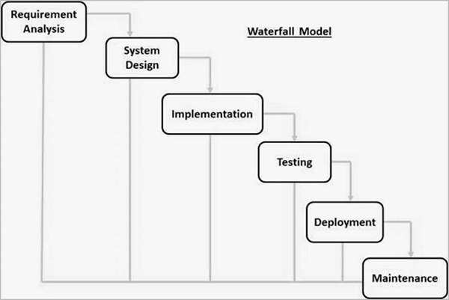

**Requirements Analysis:**

The first phase involves understanding what needs to design and what is its function, purpose, etc. The specifications of the input and output or the final product are studied and marked.

**System Design**:

System Design helps in specifying hardware and system requirements and also helps in defining overall system architecture. The software code to be written in the next stage is created now.

**Implementation:**

With inputs from system design, the system is first developed in small programs called units, which are integrated into the next phase. Each unit is developed and tested for its functionality which is referred to as Unit Testing.

**Testing:**

All the units developed in the implementation phase are integrated into a system after testing of each unit. The software needs to go through constant software testing to find out if there are any flaws or errors. Testing is done so that the client does not face any problem during the installation of the software.

**Deployment of System:**

Once the functional and non-functional testing is done, the product is deployed in the customer environment or released into the market.

**Maintenance**:

This step involves making modifications to the system or an individual component to alter attributes or improve performance. These modifications arise either due to change requests initiated by the customer, or defects uncovered during live use of the system.

# Implementation and Testing

## Metric to choose the best model

**Root Mean Square Error** (RMSE) is the standard deviation of the residuals (prediction errors). Residuals are a measure of how far from the regression line data points are; RMSE is a measure of how spread out these residuals are. In other words, it tells you how concentrated the data is around the line of best fit.

**Mean Absolute Percentage Error** (MAPE) is the mean or average of the absolute percentage errors of forecasts. Error is defined as actual or observed value minus the forecasted value. In other words, it tells you how close the forecast is from the actual value overall in percentage. (e.g. 5%)

**Mean Absolute Error (MAE)** measures the average magnitude of the errors in a set of predictions, without considering their direction. It’s the average over the test sample of the absolute differences between prediction and actual observation where all individual differences have equal weight. In other words, it tells you on average how close the forecast is to the actual value (e.g. +- 5.0)

The team has decided to make the choices of **Mean Absolute Error (MAE)** and **Mean Absolute Percentage Error** (MAPE) as the forecast proves to be a better option when the value to the actual value is closer.

## Comparison between ARIMA and Prophet Model

**Prophet Model**

**MeanTemp**

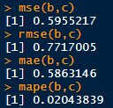

**MaxTemp**

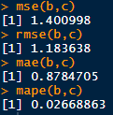

**MinTemp**

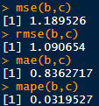

**MeanWindSpd**

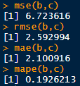

**MaxWindSpd**

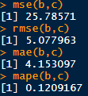

**ARIMA Model**

**MeanTemp**

**MaxTemp**



**MinTemp**



**MeanWindSpd**



**MaxWindSpd**



|  |  |  |  |  |  |
| --- | --- | --- | --- | --- | --- |
| Model/feature | MeanTemp | MaxTemp | MinTemp | MeanWindSpd | MaxWindSpd |
| Prophet | **2% / +- 0.58** | **2.7% / +- 0.88** | **3.2% / +- 0.84** | 19% / +- 2.10 | **12% / +- 4.15** |
| Arima | 2.23% +- 0.62 | 3.1% +- 0.94 | 3.4% / +- 0.85 | **18.4% / +- 1.5** | 15.4%/ +- 4.84 |

After comparison between the 2 models, the prophet model performs better in 4 of the 5 features tested, thus we shall use the prophet model.

Comparison between years to use for training data(1,2,5,10 years), First picture is how well the model is able to grasp the trend of the dataset, second picture is the training set metrics, third picture is the testing set(actual 2020 values) metrics

**1 year**

**MeanTemp**

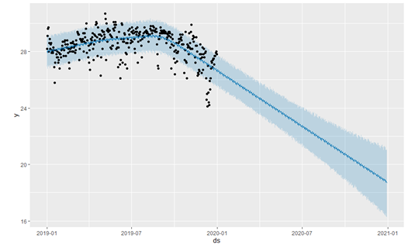

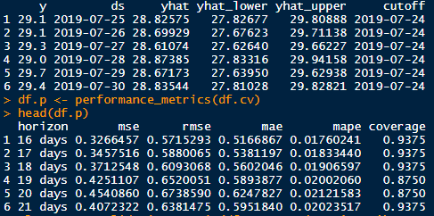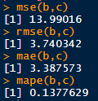

For training set, On average, 1.8% difference from actual value, +- 0.52 from actual value

For test set, On average, 13% difference from actual value, +- 3.39 from actual value

**1 year**

**MaxTemp**

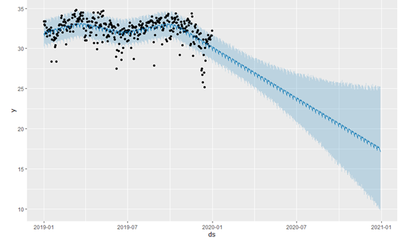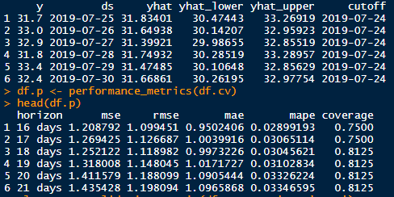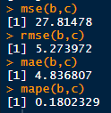

For training set, On average, 2.9% difference from actual value, +- 0.95 from actual value

For test set, On average, 18% difference from actual value, +- 4.84 from actual value

**1 year**

**MinTemp**

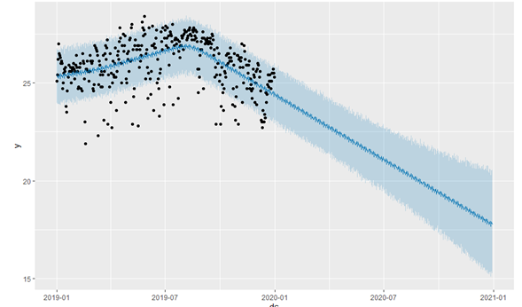

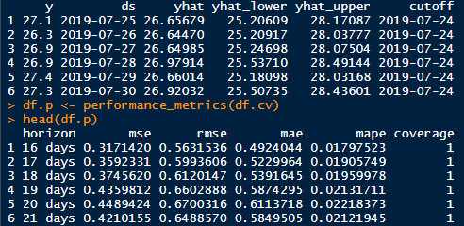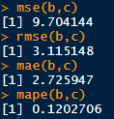

For training set, On average, 1.8% difference from actual value, +- 0.49 from actual value

For test set, On average, 12% difference from actual value, +- 2.72 from actual value

**1 year**

**MeanWindSpd**

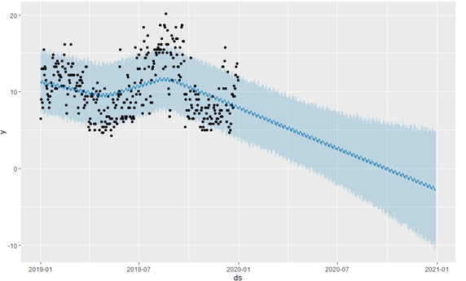

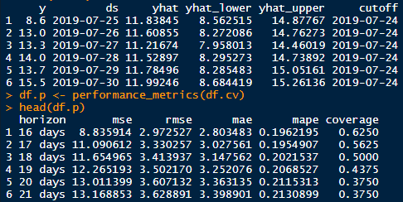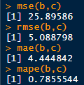

For training set, On average, 20% difference from actual value, +- 2.80 from actual value

For test set, On average, 78% difference from actual value, +- 4.44 from actual value

**1 year**

**MaxWindSpd**

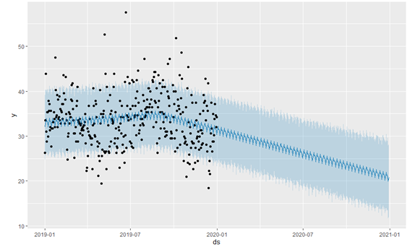

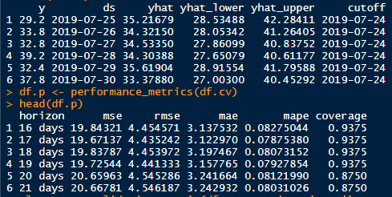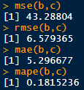

For training set, On average, 8.3% difference from actual value, +- 3.14 from actual value

For test set, On average, 18% difference from actual value, +- 5.30 from actual value

**2 years**

**MeanTemp**

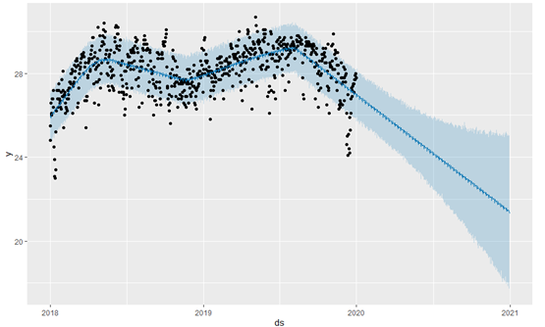

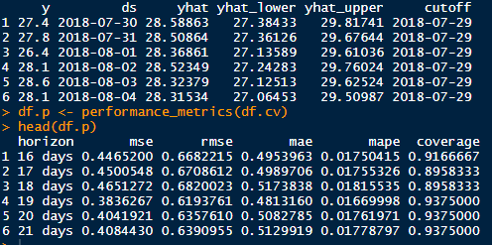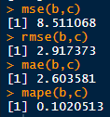

For training set, On average, 1.8% difference from actual value, +- 0.50 from actual value

For test set, On average, 10% difference from actual value, +- 2.60 from actual value

**2 years**

**MaxTemp**

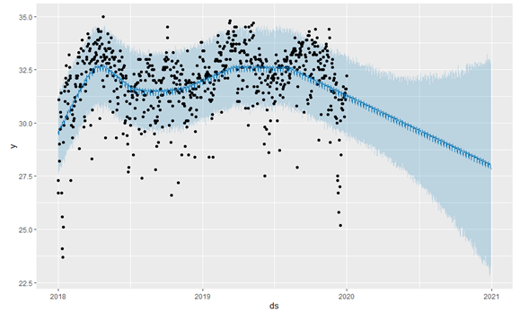

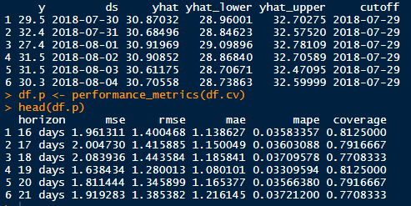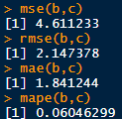

For training set, On average, 3.6% difference from actual value, +- 1.14 from actual value

For test set, On average, 6.0% difference from actual value, +- 1.84 from actual value

**2 years**

**MinTemp**

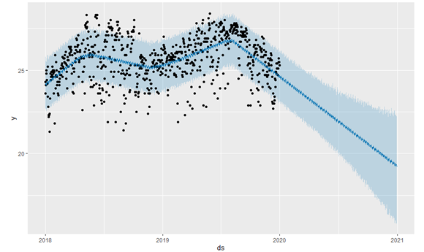

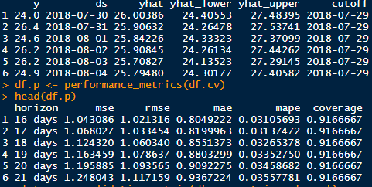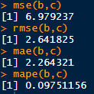

For training set, On average, 3.1% difference from actual value, +- 0.80 from actual value

For test set, On average, 9.8% difference from actual value, +- 2.26 from actual value

**2 years**

**MeanWindSpd**

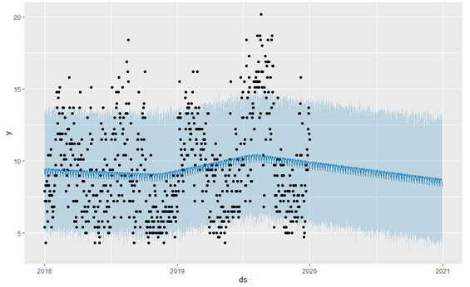

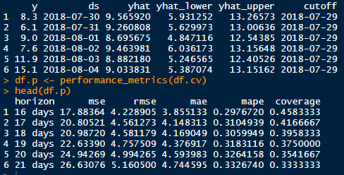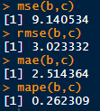

For training set, On average, 30% difference from actual value, +- 3.90 from actual value

For test set, On average, 26% difference from actual value, +- 2.51 from actual value

**2 years**

**MaxWindSpd**

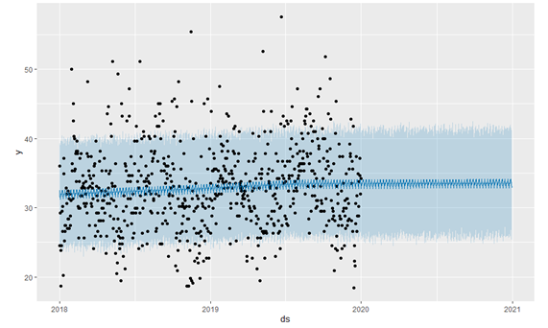

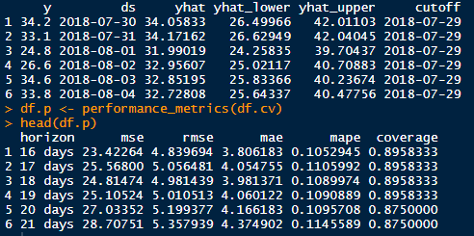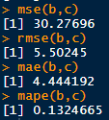

For training set, On average, 10.5% difference from actual value, +- 3.81 from actual value

For test set, On average, 13.2% difference from actual value, +- 4.44 from actual value

**5 years**

**MeanTemp**

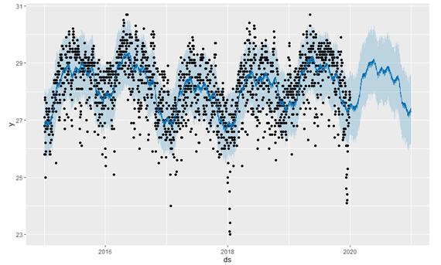

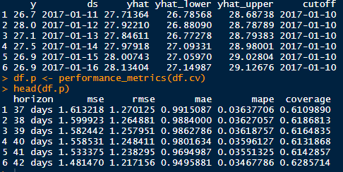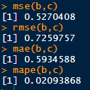

For training set, On average, 3.6% difference from actual value, +- 1.0 from actual value

For test set, On average, 2.1% difference from actual value, +- 0.59 from actual value

**5 years**

**MaxTemp**

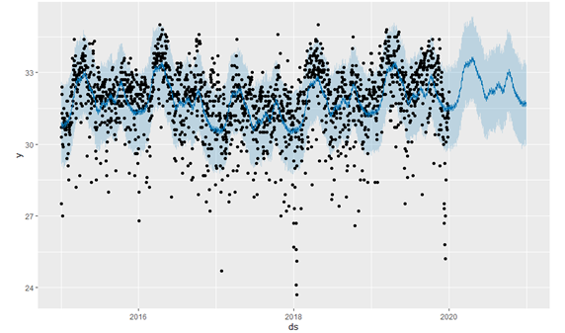

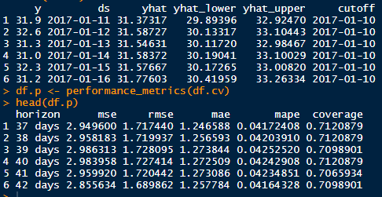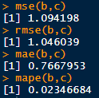

For training set, On average, 4.1% difference from actual value, +- 1.25 from actual value

For test set, On average, 2.3% difference from actual value, +- 0.77 from actual value

**5 years**

**MinTemp**

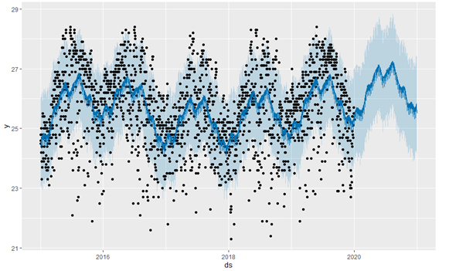

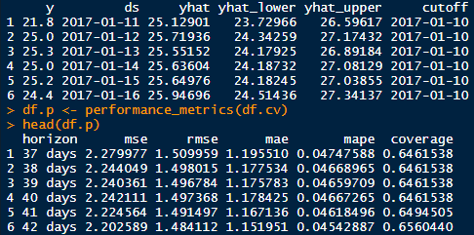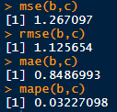

For training set, On average, 4.7% difference from actual value, +- 1.20 from actual value

For test set, On average, 3.2% difference from actual value, +- 0.85 from actual value

**5 years**

**MeanWindSpd**

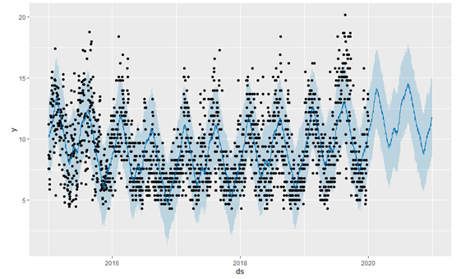

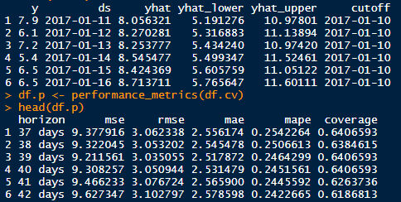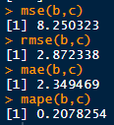

For training set, On average, 25% difference from actual value, +- 2.56 from actual value

For test set, On average, 20% difference from actual value, +- 2.34 from actual value

**5 years**

**MaxWindSpd**

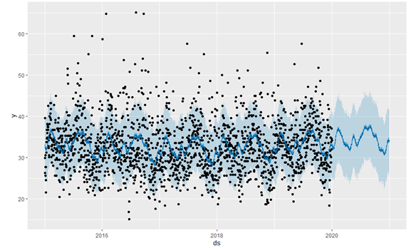

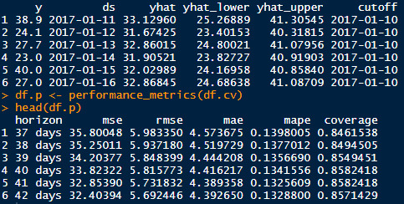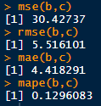

For training set, On average, 14% difference from actual value, +- 4.57 from actual value

For test set, On average, 13% difference from actual value, +- 4.41 from actual value

**10 years**

**MeanTemp**

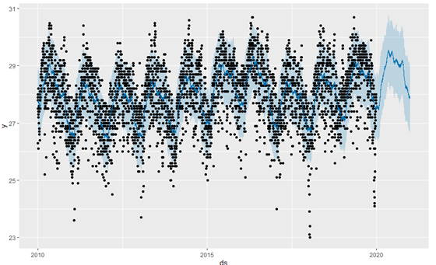

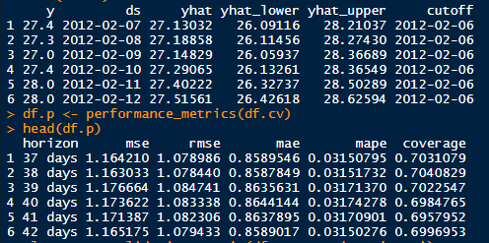

For training set, On average, 3.2% difference from actual value, +- 0.86 from actual value

For test set, On average, 2% difference from actual value, +- 0.59 from actual value

**10 years**

**MaxTemp**

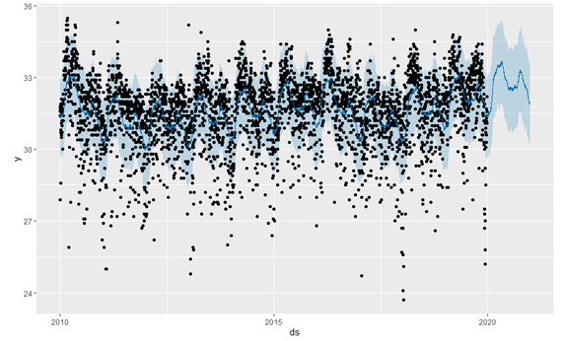

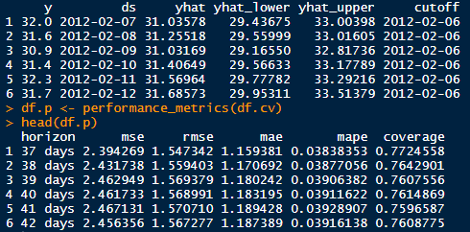

For training set, On average, 3.8% difference from actual value, +- 1.16 from actual value

For test set, On average, 2.7% difference from actual value, +- 0.88 from actual value

**10 years**

**MinTemp**

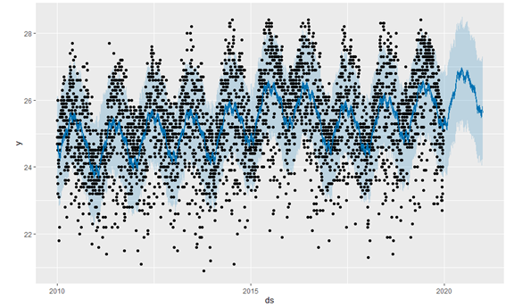

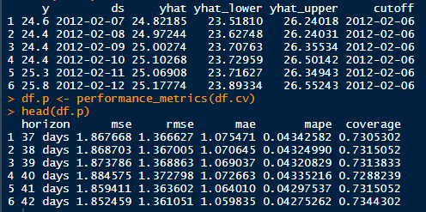

For training set, On average, 4.3% difference from actual value, +- 1.08 from actual value

For test set, On average, 3.1% difference from actual value, +- 0.83 from actual value

**10 years**

**MeanWindSpd**

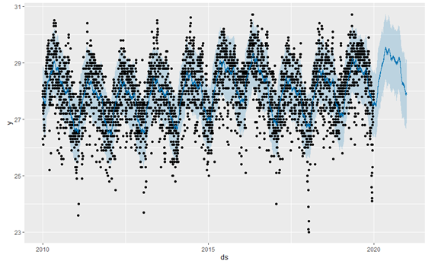

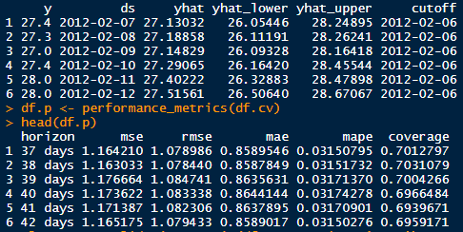

For training set, On average, 3.1% difference from actual value, +- 0.86 from actual value

For test set, On average, 19% difference from actual value, +- 2.10 from actual value

**10 years**

**MaxWindSpd**

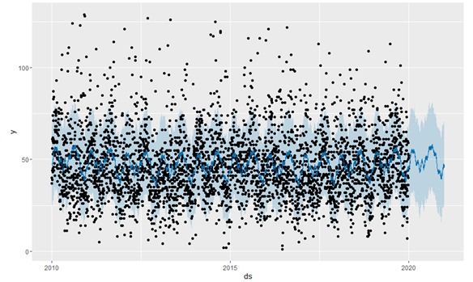

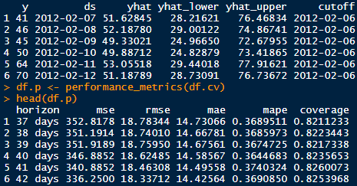

For training set, On average, 36.9% difference from actual value, +- 14.7 from actual value

For test set, On average, 12% difference from actual value, +- 4.15 from actual value

|  |  |  |  |  |  |
| --- | --- | --- | --- | --- | --- |
| Years/feature | MeanTemp | MaxTemp | MinTemp | MeanWindSpd | MaxWindSpd |
| 1 | 13% / +- 3.39 | 18% / +- 4.84 | 12% / +- 2.72 | 78% / +- 4.44 | 18% / +- 5.30 |
| 2 | 10% / +- 2.60 | 6.0% / +- 1.84 | 9.8% / +- 2.26 | 26% / +- 2.51 | 13.2% / +- 4.44 |
| 5 | 2.1% / +- 0.59 | **2.3% / +- 0.77** | 3.2% / +- 0.85 | 20% / +- 2.34 | 13.0% / +- 4.41 |
| 10 | **2% / +- 0.58** | 2.7% / +- 0.88 | **3.1 %/ +- 0.83** | **19% / +- 2.10** | **12% / +- 4.15** |

After elaborate testing on each of the 1,2,5,10 years of dataset respectively, the team realizes that by only having 1 or 2 years of dataset, the model relatively is unable to capture the trend of the dataset due to an insufficiency of data. As for 5 years and 10 years, the model was able to grasp the trend of the dataset and obtain closer values as to the actual value in comparison to 1 or 2 years. After comparing the 5 years and 10 years dataset, the results shown proves that the 10 years dataset has in fact, generated a slightly better result. Thus, it can be concluded that when there are more data available, the result of the model would be much more optimal as it will be able to capture the trend of the dataset and predict more accurately.

## User Interface

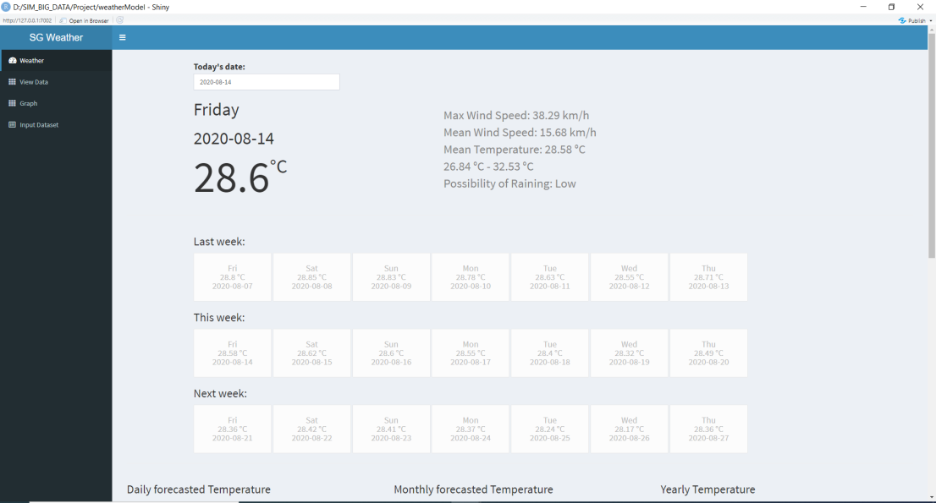

Picture above depicts the User Interface page for weather tab that displays the infographic for today as well as several other tabs for users to select in accordance to what infographic is desired. Located at the bottom of the page is the daily, monthly and yearly forecasted temperature values.

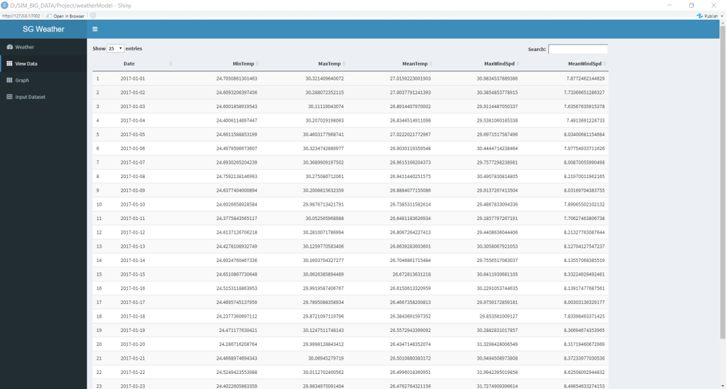

Picture above depicts the User interface page for the View Data tab which displays a table of the forecasted values of the dataset which is filterable by the different columns

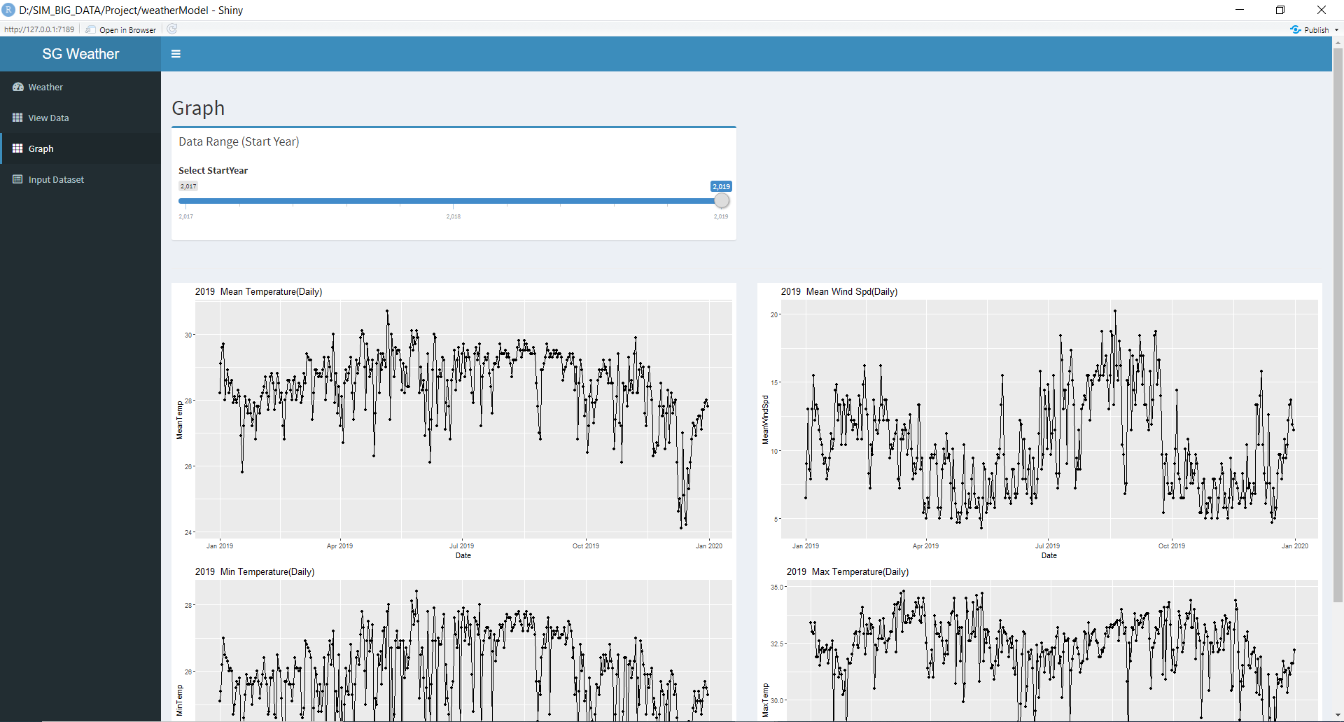

Picture above depicts the User interface for the Graph Tab, in which users are able to scroll through the various years and understand the trend over the years

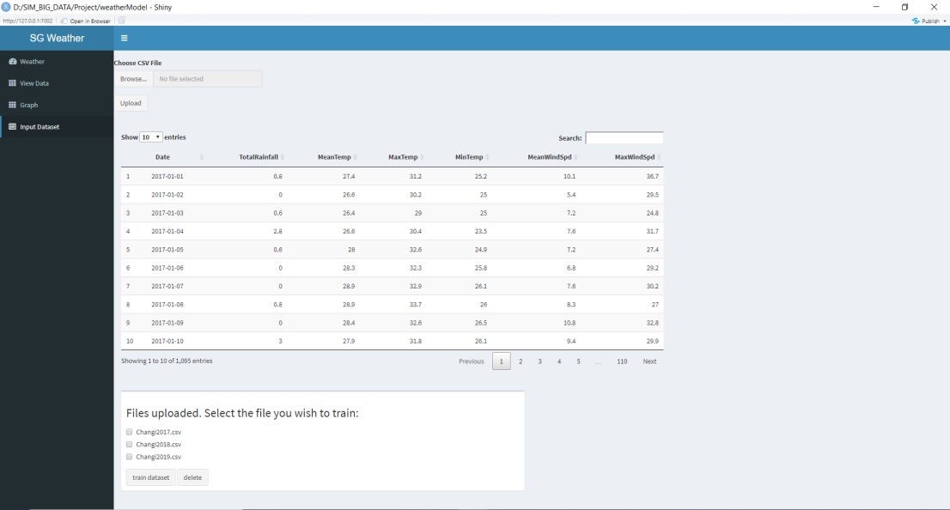

Picture above depicts the User Interface page for Input Dataset Tab, in which users are able to input their dataset for future forecasts.

## Activity Diagram

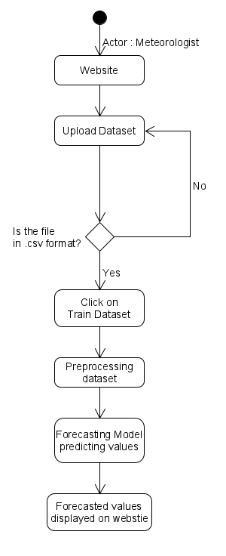

## Sequence Diagram

# 

# 

# 

# 

# 

# 

# 

# Testing Plan

## Introduction

The product being tested is a data analysing tool that allows users to view predicted/past weather data and weather trends as a visual representation. Users can also input their data files to obtain their own weather predictions. This test plan will be used for the team to document test cases and results of functions, in an orderly manner.

These functions includes:

1. Display current, next and past week’s weather forecast information.
2. Display current, next and past month’s weather forecast information.
3. Display past years’ weather data.
4. Display average of a period of time (week, month, year).
5. Search for specific values
6. Display graphs of mean values of specific years.
7. Display weather forecast filtered by factors.
8. Insert data files for prediction.
9. Delete unwanted year’s dataset from input.

## Scope

All functions of the product will be tested during implementation, following the waterfall methodology. All high priority requirements will be tested during and after implementation.

## Approach

Adopting the waterfall model methodology, the testing will be done progressively. Testing of each function tabs can be done simultaneously while new functions are being implemented. As the tabs will not affect each other, each tab function can be tested on its own. If an individual test case fails, it will be debugged and re-tested till it is fixed.

## Function Tab Units

1. Weather
2. View Data
3. Past Year
4. Input Dataset

## Test Schedule, Roles and Responsibilities

|  |  |  |  |  |
| --- | --- | --- | --- | --- |
| **Steps** | | **Start Date** | **End Date** | **Person Responsible** |
| 1 | Build test plan | 03/08/2020 | 03/08/2020 | Shu Min |
| 2 | Develop test cases | 04/08/2020 | 07/08/2020 | Everyone |
| 3 | Unit Testing | 10/08/2020 | 12/08/2020 | Everyone |
| 4 | Full Program Test | 13/08/2020 | 13/08/2020 | Everyone |
| 5 | Review test plan | 13/08/2020 | 13/08/2020 | Shu Min |

## 

## 

## 

## 

## 

## 

## 

## 

## 

## Individual Function Tab Units Test Cases

|  |  |  |  |  |  |  |  |
| --- | --- | --- | --- | --- | --- | --- | --- |
| **Test Title:** Hide and unhide sidebar | | | | | **Test case ID:** 0-1 | | |
| **Test Priority:** Low | | | | | **Date tested:** 12/08/20 | | |
| **Module Name:** - | | | | | **Tested by:** Choun Kiat | | |
| **Test Description:** Clicking on button on header should hide/unhide sidebar | | | | | | | |
| **Pre-condition:** User entered website | | | | | | | |
| **Post-condition:** N/A | | | | | | | |
| **Step** | **Test Steps** | **Test Data** | **Expected results** | **Actual Results** | | **Status (Pass/Fail)** | **Notes** |
| **1** | Click on button on header |  | Sidebar should be hidden. (default = unhidden) | Sidebar is hidden. | | Pass |  |
| **2** | Click on the button again. |  | Sidebar should appear. | Sidebar is unhidden. | | Pass |  |

|  |  |  |  |  |  |  |  |
| --- | --- | --- | --- | --- | --- | --- | --- |
| **Test Title:** Display of Weather Information of current day | | | | | **Test case ID:** 1-1 | | |
| **Test Priority:** Medium | | | | | **Date tested:** 12/08/20 | | |
| **Module Name:** Weather Tab | | | | | **Tested by:** Choun Kiat | | |
| **Test Description:** Weather Tab - Display of current day’s information | | | | | | | |
| **Pre-condition:** User entered website, clicked on weather tab | | | | | | | |
| **Post-condition:** N/A | | | | | | | |
| **Step** | **Test Steps** | **Test Data** | **Expected results** | **Actual Results** | | **Status (Pass/Fail)** | **Notes** |
| **1** | Click on weather tab |  | Forecasted values correctly displayed on website | Values displayed on website successfully | | Pass |  |

|  |  |  |  |  |  |  |  |
| --- | --- | --- | --- | --- | --- | --- | --- |
| **Test Title:** View Last Week Data Tab | | | | | **Test case ID:** 1-2 | | |
| **Test Priority:** High | | | | | **Date tested:** 12/08/20 | | |
| **Module Name:** Weather | | | | | **Tested by:** Choun Kiat | | |
| **Test Description:** Weather - Buttons changes displayed values accordingly | | | | | | | |
| **Pre-condition:** User entered website, clicked on weather tab | | | | | | | |
| **Post-condition:** N/A | | | | | | | |
| **Step** | **Test Steps** | **Test Data** | **Expected results** | **Actual Results** | | **Status (Pass/Fail)** | **Notes** |
| **1** | Click on the individual Last Week tabs |  | Display of weather information changed accordingly to tabs clicked on | Weather information changed correctly | | Pass |  |

|  |  |  |  |  |  |  |  |
| --- | --- | --- | --- | --- | --- | --- | --- |
| **Test Title:** View Current Week Data Tab | | | | | **Test case ID:** 1-3 | | |
| **Test Priority:** High | | | | | **Date tested:** 12/08/20 | | |
| **Module Name:** Weather | | | | | **Tested by:** Choun Kiat | | |
| **Test Description:** Weather - Buttons changes displayed values accordingly | | | | | | | |
| **Pre-condition:** User entered website, clicked on weather tab | | | | | | | |
| **Post-condition:** N/A | | | | | | | |
| **Step** | **Test Steps** | **Test Data** | **Expected results** | **Actual Results** | | **Status (Pass/Fail)** | **Notes** |
| **1** | Click on the individual Current Week tabs |  | Display of weather information changed accordingly to tabs clicked on | Weather information changed correctly | | Pass |  |

|  |  |  |  |  |  |  |  |
| --- | --- | --- | --- | --- | --- | --- | --- |
| **Test Title:** View Next Week Data Tab | | | | | **Test case ID:** 1-4 | | |
| **Test Priority:** High | | | | | **Date tested:** 12/08/20 | | |
| **Module Name:** Weather | | | | | **Tested by:** Choun Kiat | | |
| **Test Description:** Weather - Buttons changes displayed values accordingly | | | | | | | |
| **Pre-condition:** User entered website, clicked on weather tab | | | | | | | |
| **Post-condition:** N/A | | | | | | | |
| **Step** | **Test Steps** | **Test Data** | **Expected results** | **Actual Results** | | **Status (Pass/Fail)** | **Notes** |
| **1** | Click on the individual Next Week tabs |  | Display of weather information changed accordingly to tabs clicked on | Weather information changed incorrectly for one of the tabs | | Fail |  |

|  |  |  |  |  |  |  |  |
| --- | --- | --- | --- | --- | --- | --- | --- |
| **Test Title:** View Next Week Data Tab | | | | | **Test case ID:** 1-4.1 | | |
| **Test Priority:** High | | | | | **Date tested:** 12/08/20 | | |
| **Module Name:** Weather | | | | | **Tested by:** Choun Kiat | | |
| **Test Description:** Weather - Buttons changes displayed values accordingly | | | | | | | |
| **Pre-condition:** User entered website, clicked on weather tab | | | | | | | |
| **Post-condition:** N/A | | | | | | | |
| **Step** | **Test Steps** | **Test Data** | **Expected results** | **Actual Results** | | **Status (Pass/Fail)** | **Notes** |
| **1** | Click on the individual Next Week tabs |  | Display of weather information changed accordingly to tabs clicked on | Weather information changed accordingly. | | Pass | Edited code to get from the current week. Retested and fixed from ID 1-4. |

|  |  |  |  |  |  |  |  |
| --- | --- | --- | --- | --- | --- | --- | --- |
| **Test Title:** Display of temperature values for daily forecasted values | | | | | **Test case ID:** 1-5 | | |
| **Test Priority:** Medium | | | | | **Date tested:** 12/08/20 | | |
| **Module Name:** Weather | | | | | **Tested by:** Choun Kiat | | |
| **Test Description:** Values of daily forecasted temperature shown correctly | | | | | | | |
| **Pre-condition:** User entered website, clicked on weather tab | | | | | | | |
| **Post-condition:** N/A | | | | | | | |
| **Step** | **Test Steps** | **Test Data** | **Expected results** | **Actual Results** | | **Status (Pass/Fail)** | **Notes** |
| **1** | Click on weather tab |  | Forecasted values in dataframe be correctly displayed on website | Values displayed correctly on website | | Pass |  |

|  |  |  |  |  |  |  |  |
| --- | --- | --- | --- | --- | --- | --- | --- |
| **Test Title:** Display of temperature values for monthly forecasted values | | | | | **Test case ID:** 1-6 | | |
| **Test Priority:** Medium | | | | | **Date tested:** 12/08/20 | | |
| **Module Name:** Weather | | | | | **Tested by:** Choun Kiat | | |
| **Test Description:** Values of monthly forecasted temperature shown correctly | | | | | | | |
| **Pre-condition:** User entered website, clicked on weather tab | | | | | | | |
| **Post-condition:** N/A | | | | | | | |
| **Step** | **Test Steps** | **Test Data** | **Expected results** | **Actual Results** | | **Status (Pass/Fail)** | **Notes** |
| **1** | Click on weather tab |  | Forecasted values in dataframe be correctly displayed on website | Values displayed correctly on website | | Pass |  |

|  |  |  |  |  |  |  |  |
| --- | --- | --- | --- | --- | --- | --- | --- |
| **Test Title:** Display of temperature values for yearly forecasted values | | | | | **Test case ID:** 1-7 | | |
| **Test Priority:** Medium | | | | | **Date tested:** 12/08/20 | | |
| **Module Name:** Weather | | | | | **Tested by:** Choun Kiat | | |
| **Test Description:** Values of yearly forecasted temperature shown correctly | | | | | | | |
| **Pre-condition:** User entered website, clicked on weather tab | | | | | | | |
| **Post-condition:** N/A | | | | | | | |
| **Step** | **Test Steps** | **Test Data** | **Expected results** | **Actual Results** | | **Status (Pass/Fail)** | **Notes** |
| **1** | Click on weather tab |  | Forecasted values in dataframe be correctly displayed on website | Values displayed correctly on website | | Pass |  |

|  |  |  |  |  |  |  |  |
| --- | --- | --- | --- | --- | --- | --- | --- |
| **Test Title:** View full data of forecasted values from model | | | | | **Test case ID:** 2-1 | | |
| **Test Priority:** High | | | | | **Date tested:** 12/08/20 | | |
| **Module Name:** View Data | | | | | **Tested by:** Elvis | | |
| **Test Description:** Values of forecasted data is shown correctly | | | | | | | |
| **Pre-condition:** User entered website, clicked on View Data tab | | | | | | | |
| **Post-condition:** N/A | | | | | | | |
| **Step** | **Test Steps** | **Test Data** | **Expected results** | **Actual Results** | | **Status (Pass/Fail)** | **Notes** |
| **1** | Click on View data tab |  | Values of forecasted data is shown correctly on the website(default filtered by date) | Values displayed correctly on website | | Pass |  |

|  |  |  |  |  |  |  |  |
| --- | --- | --- | --- | --- | --- | --- | --- |
| **Test Title:** Specify number of entries to display | | | | | **Test case ID:** 2-2 | | |
| **Test Priority:** Low | | | | | **Date tested:** 12/08/20 | | |
| **Module Name:** View Data | | | | | **Tested by:** Elvis | | |
| **Test Description:** Number of data displayed corresponds with value selected. | | | | | | | |
| **Pre-condition:** ser entered website, clicked on View Data tab | | | | | | | |
| **Post-condition:** N/A | | | | | | | |
| **Step** | **Test Steps** | **Test Data** | **Expected results** | **Actual Results** | | **Status (Pass/Fail)** | **Notes** |
| **1** | Click on View Data tab |  | Values of forecasted data is shown correctly on the website (default filtered by date) | Values displayed correctly on website | | Pass |  |
| **2** | Click on the drop down box to select value. (default entries shown = 25) | Values available = 10, 25, 50, 100 | Number of entries displayed should correspond with the value selected. | Number of entries corresponds with value selected. | | Pass |  |

|  |  |  |  |  |  |  |  |
| --- | --- | --- | --- | --- | --- | --- | --- |
| **Test Title:** Filter table by date | | | | | **Test case ID:** 2-3 | | |
| **Test Priority:** Low | | | | | **Date tested:** 12/08/20 | | |
| **Module Name:** View Data | | | | | **Tested by:** Elvis | | |
| **Test Description:** Filter table by date column | | | | | | | |
| **Pre-condition:** User entered website, clicked on View Data tab | | | | | | | |
| **Post-condition:** N/A | | | | | | | |
| **Step** | **Test Steps** | **Test Data** | **Expected results** | **Actual Results** | | **Status (Pass/Fail)** | **Notes** |
| **1** | Click on date filter |  | Values will be filtered by date(ascending) | Values filtered correctly and displayed correctly | | Pass |  |
| **2** | Click on date filter again |  | Values will be filtered by date(descending) | Values filtered correctly and displayed correctly | | Pass |  |

|  |  |  |  |  |  |  |  |
| --- | --- | --- | --- | --- | --- | --- | --- |
| **Test Title:** Filter table by Minimum Temperature | | | | | **Test case ID:** 2-4 | | |
| **Test Priority:** Low | | | | | **Date tested:** 12/08/20 | | |
| **Module Name:** View Data | | | | | **Tested by:** Elvis | | |
| **Test Description:** Filter table by MinTemp column | | | | | | | |
| **Pre-condition:** User entered website, clicked on View Data tab | | | | | | | |
| **Post-condition:** N/A | | | | | | | |
| **Step** | **Test Steps** | **Test Data** | **Expected results** | **Actual Results** | | **Status (Pass/Fail)** | **Notes** |
| **1** | Click on MinTemp filter |  | Values will be filtered by MinTemp (ascending) | Values filtered correctly and displayed correctly | | Pass |  |
| **2** | Click on MinTemp filter again |  | Values will be filtered by MinTemp (descending) | Values filtered correctly and displayed correctly | | Pass |  |

|  |  |  |  |  |  |  |  |
| --- | --- | --- | --- | --- | --- | --- | --- |
| **Test Title:** Filter table by Max Temperature | | | | | **Test case ID:** 2-5 | | |
| **Test Priority:** Low | | | | | **Date tested:** 12/08/20 | | |
| **Module Name:** View Data | | | | | **Tested by:** Elvis | | |
| **Test Description:** Filter table by MaxTemp column | | | | | | | |
| **Pre-condition:** User entered website, clicked on View Data tab | | | | | | | |
| **Post-condition:** N/A | | | | | | | |
| **Step** | **Test Steps** | **Test Data** | **Expected results** | **Actual Results** | | **Status (Pass/Fail)** | **Notes** |
| **1** | Click on MaxTemp filter |  | Values will be filtered by MaxTemp (ascending) | Values filtered correctly and displayed correctly | | Pass |  |
| **2** | Click on MaxTemp filter again |  | Values will be filtered by MaxTemp (descending) | Values filtered correctly and displayed correctly | | Pass |  |

|  |  |  |  |  |  |  |  |
| --- | --- | --- | --- | --- | --- | --- | --- |
| **Test Title:** Filter table by Mean Temperature | | | | | **Test case ID:** 2-6 | | |
| **Test Priority:** Low | | | | | **Date tested:** 12/08/20 | | |
| **Module Name:** View Data | | | | | **Tested by:** Elvis | | |
| **Test Description:** Filter table by MeanTemp column | | | | | | | |
| **Pre-condition:** User entered website, clicked on View Data tab | | | | | | | |
| **Post-condition:** N/A | | | | | | | |
| **Step** | **Test Steps** | **Test Data** | **Expected results** | **Actual Results** | | **Status (Pass/Fail)** | **Notes** |
| **1** | Click on MeanTemp filter |  | Values will be filtered by MeanTemp (ascending) | Values filtered correctly and displayed correctly | | Pass |  |
| **2** | Click on MeanTempfilter again |  | Values will be filtered by MeanTemp (descending) | Values filtered correctly and displayed correctly | | Pass |  |

|  |  |  |  |  |  |  |  |
| --- | --- | --- | --- | --- | --- | --- | --- |
| **Test Title:** Filter table by Maximum Wind Speed | | | | | **Test case ID:** 2-7 | | |
| **Test Priority:** Low | | | | | **Date tested:** 12/08/20 | | |
| **Module Name:** View Data | | | | | **Tested by:** Elvis | | |
| **Test Description:** Filter table by MaxWindSpd column | | | | | | | |
| **Pre-condition:** User entered website, clicked on View Data tab | | | | | | | |
| **Post-condition:** N/A | | | | | | | |
| **Step** | **Test Steps** | **Test Data** | **Expected results** | **Actual Results** | | **Status (Pass/Fail)** | **Notes** |
| **1** | Click on MaxWindSpd filter |  | Values will be filtered by maximum wind speed(ascending) | Values filtered correctly and displayed correctly | | Pass |  |
| **2** | Click on MaxWindSpd filter again |  | Values will be filtered by maximum wind speed(descending) | Values filtered correctly and displayed correctly | | Pass |  |

|  |  |  |  |  |  |  |  |
| --- | --- | --- | --- | --- | --- | --- | --- |
| **Test Title:** Filter table by Mean Wind Speed | | | | | **Test case ID:** 2-8 | | |
| **Test Priority:** Low | | | | | **Date tested:** 12/08/20 | | |
| **Module Name:** View Data | | | | | **Tested by:** Elvis | | |
| **Test Description:** Filter table by MeanWindSpd column | | | | | | | |
| **Pre-condition:** User entered website, clicked on View Data tab | | | | | | | |
| **Post-condition:** N/A | | | | | | | |
| **Step** | **Test Steps** | **Test Data** | **Expected results** | **Actual Results** | | **Status (Pass/Fail)** | **Notes** |
| **1** | Click on MeanWindSpd filter |  | Values will be filtered by mean wind speed(ascending) | Values filtered correctly and displayed correctly | | Pass |  |
| **2** | Click on MeanWindSpd filter again |  | Values will be filtered by mean wind speed(descending) | Values filtered correctly and displayed correctly | | Pass |  |

|  |  |  |  |  |  |  |  |
| --- | --- | --- | --- | --- | --- | --- | --- |
| **Test Title:** Search Bar | | | | | **Test case ID:** 2-9 | | |
| **Test Priority:** Medium | | | | | **Date tested:** 12/08/20 | | |
| **Module Name:** View Data | | | | | **Tested by:** Elvis | | |
| **Test Description:** Search for specific results from the table | | | | | | | |
| **Pre-condition:** User entered website, clicked on View Data tab | | | | | | | |
| **Post-condition:** N/A | | | | | | | |
| **Step** | **Test Steps** | **Test Data** | **Expected results** | **Actual Results** | | **Status (Pass/Fail)** | **Notes** |
| **1** | Enter the value ‘50.5’ into the search bar | 50.5 | Rows that contains the value ‘50.5’ will appear, with those without filtered away | Values filtered correctly and displayed correctly | | Pass |  |

|  |  |  |  |  |  |  |  |
| --- | --- | --- | --- | --- | --- | --- | --- |
| **Test Title:** View graphs of dataset | | | | | **Test case ID:** 3-1 | | |
| **Test Priority:** Medium | | | | | **Date tested:** 12/08/20 | | |
| **Module Name:** Graphs | | | | | **Tested by:** Chin Leong | | |
| **Test Description:** Graph view | | | | | | | |
| **Pre-condition:** User entered website, clicked on Graphs tab | | | | | | | |
| **Post-condition:** N/A | | | | | | | |
| **Step** | **Test Steps** | **Test Data** | **Expected results** | **Actual Results** | | **Status (Pass/Fail)** | **Notes** |
| **1** | Click on graphs tab |  | Graph of a specific column should be displayed correctly(default - most recent year) | Graph displayed correctly | | Pass |  |

|  |  |  |  |  |  |  |  |
| --- | --- | --- | --- | --- | --- | --- | --- |
| **Test Title:** View graphs of specific year | | | | | **Test case ID:** 3-2 | | |
| **Test Priority:** Medium | | | | | **Date tested:** 12/08/20 | | |
| **Module Name:** Graphs | | | | | **Tested by:** Chin Leong | | |
| **Test Description:** Select and view Mean Temperature of specific year using the slider | | | | | | | |
| **Pre-condition:** User entered website, clicked on Graphs tab | | | | | | | |
| **Post-condition:** N/A | | | | | | | |
| **Step** | **Test Steps** | **Test Data** | **Expected results** | **Actual Results** | | **Status (Pass/Fail)** | **Notes** |
| **1** | Click on graphs tab |  | Graph of a specific column should be displayed correctly(default - most recent year) | Graph displayed correctly | | Pass |  |
| **2** | Click on the slider and slide to a specific year. | 2010 - 2019 | Values of year 2010-2019 should be displayed correctly in graph form. | Graph of 2010-2019 is displayed correctly. | | Pass |  |

|  |  |  |  |  |  |  |  |
| --- | --- | --- | --- | --- | --- | --- | --- |
| **Test Title:** Selecting file to upload | | | | | **Test case ID:** 4-1 | | |
| **Test Priority:** High | | | | | **Date tested:** 12/08/20 | | |
| **Module Name:** Input Dataset | | | | | **Tested by:** Shu Min | | |
| **Test Description:** Uploading files to be used | | | | | | | |
| **Pre-condition:** User entered website, clicked on Input Dataset tab | | | | | | | |
| **Post-condition:** N/A | | | | | | | |
| **Step** | **Test Steps** | **Test Data** | **Expected results** | **Actual Results** | | **Status (Pass/Fail)** | **Notes** |
| **1** | Clicks on browse button |  | A window will appear for the user to select the file | Window successfully displayed | | Pass |  |
| **2** | Selects the file to be uploaded | Changi2020.csv | Name of file is displayed in the textbox beside browse button | Name of file displayed successfully | | Pass |  |
| **3** | Clicks on upload button |  | Refresh the files uploaded menu, the uploaded file is displayed. | File uploaded does not appear on the list | | Fail |  |

|  |  |  |  |  |  |  |  |
| --- | --- | --- | --- | --- | --- | --- | --- |
| **Test Title:** Selecting file to upload | | | | | **Test case ID:** 4-1.1 | | |
| **Test Priority:** High | | | | | **Date tested:** 12/08/20 | | |
| **Module Name:** Input Dataset | | | | | **Tested by:** Shu Min | | |
| **Test Description:** Uploading files to be used | | | | | | | |
| **Pre-condition:** User entered website, clicked on Input Dataset tab | | | | | | | |
| **Post-condition:** N/A | | | | | | | |
| **Step** | **Test Steps** | **Test Data** | **Expected results** | **Actual Results** | | **Status (Pass/Fail)** | **Notes** |
| **1** | Clicks on browse button |  | A window will appear for the user to select the file | Window successfully displayed | | Pass |  |
| **2** | Selects the file to be uploaded | Changi2020.csv | Name of file is displayed in the textbox beside browse button | Name of file displayed successfully | | Pass |  |
| **3** | Clicks on upload button |  | Refresh the files uploaded menu, the uploaded file is displayed. | Uploaded file is displayed correctly. | | Pass | Changed code from UI side to reflect the correct files. Retested and fixed from ID 4.1. |

|  |  |  |  |  |  |  |  |
| --- | --- | --- | --- | --- | --- | --- | --- |
| **Test Title:** Delete files from upload | | | | | **Test case ID:** 4-2 | | |
| **Test Priority:** High | | | | | **Date tested:** 12/08/20 | | |
| **Module Name:** Input Dataset | | | | | **Tested by:** Shu Min | | |
| **Test Description:** Uploading files to be used | | | | | | | |
| **Pre-condition:** User entered website, clicked on Input Dataset tab | | | | | | | |
| **Post-condition:** N/A | | | | | | | |
| **Step** | **Test Steps** | **Test Data** | **Expected results** | **Actual Results** | | **Status (Pass/Fail)** | **Notes** |
| **1** | Clicks on the checkbox beside the files that they wish to delete | Changi2020.csv | Checkbox beside the file will be ticked | Checkbox is ticked | | Pass |  |
| **2** | Clicks on the delete button | Changi2020.csv | Changi2020.csv will be deleted from the list | Changi2020.csv was not deleted | | Fail | File was deleted from directory but not from the list |

|  |  |  |  |  |  |  |  |
| --- | --- | --- | --- | --- | --- | --- | --- |
| **Test Title:** Delete files from upload | | | | | **Test case ID:** 4-2.1 | | |
| **Test Priority:** High | | | | | **Date tested:** 12/08/20 | | |
| **Module Name:** Input Dataset | | | | | **Tested by:** Shu Min | | |
| **Test Description:** Uploading files to be used | | | | | | | |
| **Pre-condition:** User entered website, clicked on Input Dataset tab | | | | | | | |
| **Post-condition:** N/A | | | | | | | |
| **Step** | **Test Steps** | **Test Data** | **Expected results** | **Actual Results** | | **Status (Pass/Fail)** | **Notes** |
| **1** | Clicks on the checkbox beside the files that they wish to delete | Changi2020.csv | Checkbox beside the file will be ticked | Checkbox is ticked | | Pass |  |
| **2** | Clicks on the delete button | Changi2020.csv | Changi2020.csv will be deleted from the list | Changi2020.csv was deleted | | Pass | Changed code from UI side to display the files. Retested and fixed from ID 4.2. |

|  |  |  |  |  |  |  |  |
| --- | --- | --- | --- | --- | --- | --- | --- |
| **Test Title:** Show values of files onto table(table functions) | | | | | **Test case ID:** 4-3 | | |
| **Test Priority:** High | | | | | **Date tested:** 12/08/20 | | |
| **Module Name:** Input Dataset | | | | | **Tested by:** Shu Min | | |
| **Test Description:** Table of all the values in the files displayed and functions working properly | | | | | | | |
| **Pre-condition:** User entered website, clicked on Input Dataset tab | | | | | | | |
| **Post-condition:** N/A | | | | | | | |
| **Step** | **Test Steps** | **Test Data** | **Expected results** | **Actual Results** | | **Status (Pass/Fail)** | **Notes** |
| **1** | Clicks on Input Dataset |  | Table of all the values in the files should be displayed | Table is displayed properly | | Pass |  |
| **2** | Clicks on the different filters |  | Table able to filter both ascending and descending by selected filter | Filtering has no problem | | Pass |  |
| **3** | Click on the drop down box to select value. (default entries shown = 25) | Values available = 10, 25, 50, 100 | Number of entries displayed should correspond with the value selected. | Number of entries corresponds with value selected. | | Pass |  |
| **4** | Enter the value ‘23.3’ into the search bar | 23.3 | Rows that contains the value ‘23.3’ will appear, with those without filtered away | Values filtered correctly and displayed correctly | | Pass |  |

## 

## Test risk and Mitigation / Contingency

|  |  |  |  |
| --- | --- | --- | --- |
| **Test Risk** | **Likelihood** | **Impact to project** | **Mitigation/Contingency** |
| Lack of personnel to do testing | Low | Marginal | Add more personnel to do testing or test team to work overtime. |
| Changes to original requirements | Medium | Critical | Adjust scope to adhere to new requirements |
| Delay in schedule | High | Critical | Reduce the number of tests or revise delivery schedule |

# Risk Management Strategies

## Problems Encountered with Resolutions

**Problem:**

Input of neural network required all predictor variables to be numeric or integer, some of the data types of the predictor variables are not numeric or integer

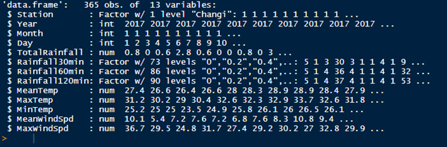

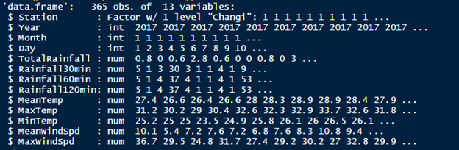

**Solution:**

Convert to character first then convert to numeric

Converted predictor variables to numeric or integer without corrupting the dataset





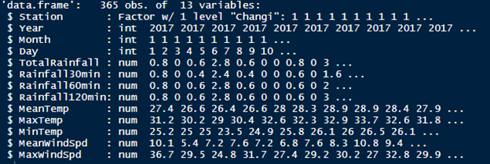

**Problem:**

The columns highest 30 min rainfall, 60 min rainfall, 120 min rainfall, for most of the dataset are null values, making it hard to fill in the missing values

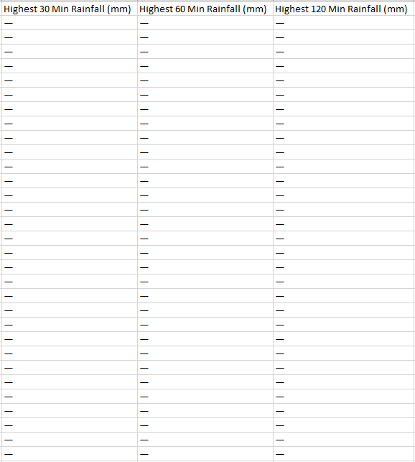

**Solution:**

As it is hard to fill in the values, we decided to remove the columns from the dataset

**Problem:**

There were missing values in the dataset utilised

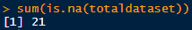

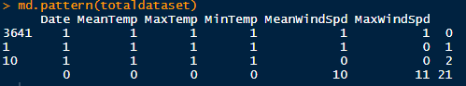

**Solution:**

Visualize the amount of missing data in dataset (mice) and used predictive mean matching (VIM) libraries to estimate the missing values

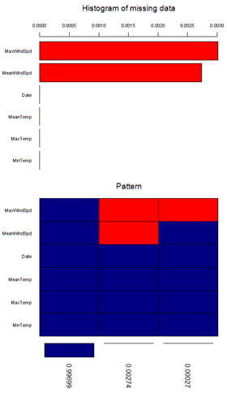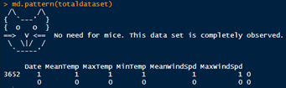

**Problem:**

The prophet model requires the date of the dataset to be in YYYY-MM-DD format, the dataset we are using has the year, month and day all separated

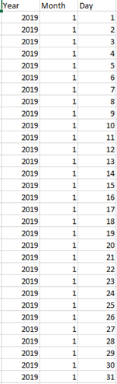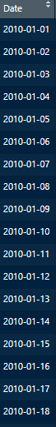

**Solution:**

To loop through the dataset and combine the values in separate columns into one singular date column

**Problem:**

The classification models that is being utilized (neural network, random forest, SVM) had underfitted and are unable to get accurate results for rainfall

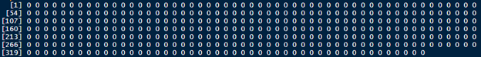

**Solution:**

We found another way not using classification models but instead use clustering to get the rainfall

## Issues and Risks Review

|  |  |  |  |  |  |
| --- | --- | --- | --- | --- | --- |
| Issue and Risk Review | | | | | |
| **Risk Level** | **Risk Description** | **Members** | **Latest Forecast** | **Commentary** |
|  | **Health Risk** | Ong Choun Kiat, Elvis Teo, Koo Shu Min, Yeo Chin Leong |  | Till the end of the project completion, members are healthy and did not fall sick, thus was able to successfully communicate and hand over the tasks to another. As such, the identified risk has been effectively resolved. |
|  | **Knowledge risk** | Ong Choun Kiat, Elvis Teo, Koo Shu Min, Yeo Chin Leong |  | Till the end of the project completion, the knowledge imparted to each member had help escalated the project towards the end goal. With the members helping one another, the identified risk had been effectively resolved |
|  | **Poor comprehension of scope** | Ong Choun Kiat, Elvis Teo, Koo Shu Min, Yeo Chin  Leong |  | Till the end of the project completion, members were able to communicate frequently in order to further understand the project scope. This in turn allows the team to mitigate risks and tailor the project to meet consumer’s need. As such, the identified risk has been effectively resolved. |
|  | **Insufficient data** | Ong Choun Kiat, Elvis Teo |  | Till the end of the project completion, with the identification of insufficient data, new researches and dataset mined had successfully allow the system to reach the desired potential. As such, the identified risk has been effectively resolved. |
|  | **Various commitments** | Ong Choun Kiat, Elvis Teo, Koo Shu Min, Yeo Chin Leong |  | Till the end of the project completion, each member was able to prioritise the project and diligently delegate different work task to different members on days where one did be unavailable. As such, the identified risk has been effectively resolved. |
|  | **Incompletion of System** | Ong Choun Kiat, Elvis Teo, Koo Shu Min, Yeo Chin Leong |  | Till the end of the project completion, each member was concerned about the timeline as there were changes to be made in terms of dataset as well as the establishment of the system. However, the identified risk has been effectively resolved upon completion of the stipulated project. |
|  | **Changes in Dataset Mining** | Ong Choun Kiat, Elvis Teo, Koo Shu Min, Yeo Chin Leong |  | Till the end of the project completion, various datasets had been compared and discussed as various requirements had to be met. However, after several meetings and testing, the identified risk has been effectively resolved. |
|  | **Prevention of Gold Plating of Scope** | Ong Choun Kiat, Elvis Teo, Koo Shu Min, Yeo Chin Leong |  | Till the end of the project completion, there are no unnecessary additions to the project requirement nor change request. All members agreed and abided by the determined Project to avoid confusion and proceeded with the project. The identified risk has been effectively resolved. |
|  | **Inadequate Estimation of Time** | Ong Choun Kiat, Elvis Teo, Koo Shu Min, Yeo Chin Leong |  | Till the end of the project completion, members had upkept the time management of each individual’s schedule without hindering the progress of the project. Notably, usage of analogous estimation helped propel the team to greater heights with the aspect of completing the task on schedule. The identified risk has been effectively resolved. |
|  | **Database Connection Failure** | Ong Choun Kiat, Elvis Teo |  | Till the end of the project completion, members had constantly trial and established a substantial database that is functional. Notably, this had been a huge success as it allows the team to identify the changes that needed to be made upon testing. The identified risk has been effectively resolved. |
|  | **Inadequate Testing of System after Completion** | Ong Choun Kiat, Elvis Teo |  | Till the end of the project completion, members had constantly trial and established a substantial Weather Modelling System that is functional. Notably, the team had identified the changes that needed to be made upon numerous testing in order to meet the full potential. The identified risk has been effectively resolved. |
|  | **Insufficient Flow of Information among Team Members** | Ong Choun Kiat, Elvis Teo, Koo Shu Min, Yeo Chin Leong |  | Till the end of the project completion, members were able to attend weekly meeting and was clear about their tasks, allowing members to finish their parts diligently and proceed to the next phase of the project requirements. The identified risk has been effectively resolved. |
|  | **Team Members conflict in Ideas** | Ong Choun Kiat, Elvis Teo, Koo Shu Min, Yeo Chin Leong |  | Till the end of the project completion, all members are on the same page and have agreed upon the implementation of the system without causing any conflict among members. The identified risk has been effectively resolved. |
|  | **Delay in Earlier Project Phases** | Ong Choun Kiat, Elvis Teo, Koo Shu Min, Yeo Chin Leong |  | Till the end of the project completion, deadline for each member’s tasks were thoroughly planned and members were able to finish their tasks on the given deadline, allowing members to proceed to the next phase without any delay. The identified risk has been effectively resolved |
|  | **Hardware failure** | Ong Choun Kiat, Elvis Teo |  | Till the end of the project completion, numerous backups and testes had been done as a safety net in an event of a hardware failure. The identified risk has been effectively resolved |
|  | **High expectations** | Ong Choun Kiat, Yeo Chin Leong |  | Till the end of the project completion, the project manager had honoured the expectations that had been briefed before the project commencement with members diligently cooperating with confidences and dignity. The identified risk has been effectively resolved |
|  | **Human resource** | Ong Choun Kiat, Yeo Chin Leong |  | Till the end of the project completion, the allocation of task followed a strict protocol which allows the member to work cohesively. The flexibility and communicate continues to remain on a high. The identified has been effectively resolved |
|  | **Integration of Works** | Ong Choun Kiat, Elvis Teo |  | Till the end of the project completion, a schedule determined during the course of the project allowed members to further utilise each ability and time fruitfully. The identified risk has been effectively resolved |

**For Reference**

|  |  |  |  |  |  |
| --- | --- | --- | --- | --- | --- |
| **Statuses** | No information | Low Risk | Medium Risk | High Risk Accepted Resolved | Not Applicable |

# 

# Project Progress Report

# 

## Summary

The assignment entrusted was to be implemented by 22nd August 2020, at the stipulated budget of $40,000. The tentative amount will serve as the salary for the entire project team members upon commencement of the project. However, after several discussions due to the unforeseen circumstances, the team has requested and been granted an additional budget of $10,000, which sums up the total budget to $50,000. The objective is to successfully develop and deliver a functional and competent Weather Pattern Modelling System, which must adhere to all the specifications with detailed documentation which includes the mentioned scope, designated timeframe and budget for User’s usage. Upon commencement of the project, the team had struggled to deal with the immersive pressure of completing the system within a tight time frame as the team were preoccupied by other tasks on hand. However, this did not impact the team at any point of time due to a pristine communication between the members as well as the distinct distribution of workload at any point of time. At some point, the programming algorithms prevented the team from establishing clear communication as a couple of members lacked the knowledge depth, which resulted in a minor delay as explanations were needed. However, this in turn, allowed the team to continuously perform clear communication with regards to the details of the project which had been placed on high priority. Members got to better understand the task and eased the tension that had been caused by the delay. Notably, the team had previously picked out Sydney as the preferable destination due to the immerse and distinctive data set that was being provided. However, after several of discussions and evaluation, the team has decided to mine the Sydney’s dataset for the prototype run as there are only 14 months of data before focusing on Singapore’s dataset which would substantially provide more than 5 years of dataset that could essentially and efficiently build up a more comprehensive Weather Modelling System. As such, the project is well on track and has been completed within the suggested time frame.

## Milestones

**List of milestones:**

|  |  |
| --- | --- |
| **Milestone Description** | |
| 1. | Development of Project Plans |
| 2. | Development of System Plans |
| 3. | Learning of Program |
| 4. | Project Charter |
| 5. | Project Scope |
| 6. | User Stories |
| 7. | Use Case Diagrams & Description |
| 8. | Project Stakeholder List |
| 9. | Project Risk Register |
| 10. | Project Schedule |
| 11. | Project Cost Estimate |
| 12. | 1st Milestone Project Progress Report |
| 13. | Meeting Minutes |
| 14. | Literature Review |
| 15. | System Designs |
| 16. | Building Program |
| 17. | Unit Testing for Prototype |
| 18. | Compile and Update Documentations |
| 19. | Completion of Prototype System |
| 20. | Project Dataset Changes |
| 21. | Second Model for Future Predictive Model |
| 22. | Development of Final Weather Modelling System |
| 23. | Unit Testing of Final Weather Modelling System |
| 24. | Official Completion of Weather Modelling System |
| 25. | Project Closure |

# Milestone Completion Review

**List of Completed Work Items:**

|  |  |  |  |  |
| --- | --- | --- | --- | --- |
| **Status** | **Milestone Description** | **Target** | **Latest Forecast** | **Commentary** |
| ✔ | Development of Project Plans | ✔ | ✔ | Project Plans completed on 15th April 2020 |
| ✔ | Development of System Plans | ✔ | ✔ | System Design completed on 23rd April 2020 |
| ✔ | Learning of Program | ✔ | ✔ | Research and learning of program completed on 5th May 2020 |
| ✔ | Project Charter | ✔ | ✔ | Project Charter completed on 8th May 2020. |
| ✔ | Project Scope | ✔ | ✔ | Project Scope completed on 8th May 2020. |
| ✔ | User Stories | ✔ | ✔ | User Stories completed on 8th May 2020. |
| ✔ | Use Case Diagrams & Description | ✔ | ✔ | Use Case Diagrams & Description completed on 8th May 2020. |
| ✔ | Project Stakeholder List | ✔ | ✔ | Project Stakeholder List completed on 8th May 2020. |
| ✔ | Project Risk Register | ✔ | ✔ | Project Risk Register completed on 8th May 2020. |
| ✔ | Project Schedule | ✔ | ✔ | Project Schedule completed on 8th May 2020. |
| ✔ | Project Cost Estimate | ✔ | ✔ | Project Cost Estimate completed on 8th May 2020. |
| ✔ | 1st Milestone Project Progress Report | ✔ | ✔ | 1st Milestone Project Progress Report completed on 8th May 2020. |
| ✔ | Meeting Minutes | ✔ | ✔ | Meeting Minutes completed on 8th May 2020. |
| ✔ | Literature Review | ✔ | ✔ | Literature Review completed on 8th May 2020. |
| ✔ | System Designs | ✔ | ✔ | Development of System Plans will be completed on 10th June 2020. |
| ✔ | Building Program | ✔ | ✔ | Building of Program will be completed on 10th June 2020. |
| ✔ | Unit Testing for Prototype | ✔ | ✔ | Unit Testing will be completed on 17th June 2020. |
| ✔ | Compile and Update Documentations | ✔ | ✔ | Compile and Update of Documentations will be completed on 20th June 2020. |
| ✔ | Completion of Prototype System | ✔ | ✔ | Official Weather Modelling Prototype System completed on 20th June 2020. |
| ✔ | Project Dataset Changes | ✔ | ✔ | New Datasets mining process completed on 10th July 2020. |
| ✔ | Second Model for Future Predictive Model | ✔ | ✔ | Second Model for Future Predictive Model completed on 15th July 2020. |
| ✔ | Development of Final Weather Modelling System | ✔ | ✔ | Developmentation of Final Weather Modelling System completed on 3rd August 2020. |
| ✔ | Development of Test Plan | ✔ | ✔ | Development of Test Plan completed on 4th August 2020 |
| ✔ | Development of Test Cases | ✔ | ✔ | Development of Test Plan completed on 5th August 2020 |
| ✔ | Unit Testing of Final Weather Modelling System | ✔ | ✔ | Unit Testing of Final Weather Modelling System completed on 10th August 2020. |
| ✔ | Official Completion of Weather Modelling System | ✔ | ✔ | Official Weather Modelling System completed on 14th August 2020. |
| ✔ | Project Closure | ✔ | ✔ | Project Closure completed on 15th August 2020 |

|  |  |  |  |  |  |
| --- | --- | --- | --- | --- | --- |
| **Statuses** | No information | Will achieve | Will achieve but not be date specified | Will not achieve | ✔ Completed |

**For Reference**

## Roles and Responsibility

|  |  |  |  |
| --- | --- | --- | --- |
| ***Roles and Responsibilities:*** | | | |
| **Role** | **Name** | **Organization/**  **Position** | **Contact Information** |
| **Project Manager** | **Ong Choun Kiat** | **Project Team Manager** | **ckong009@mymail.sim.edu.sg** |
| **Programmer** | **Elvis Teo Kar Lin** | **Project Team Member** | **eklteo001@mymail.sim.edu.sg** |
| **Analyst** | **Koo Shu Min** | **Project Team Member** | **smkoo001@mymail.sim.edu.sg** |
| **Analyst** | **Yeo Chin Leong** | **Project Team Member** | **clyeo005@mymail.sim.edu.sg** |
| **Project Supervisor** | **Aaron Yeo** | **Project Supervisor from University of Wollongong** | **aaronyeosw@gmail.com** |

# Project Website Link

<https://fypweathermod.blogspot.com/>

# Project Schedule

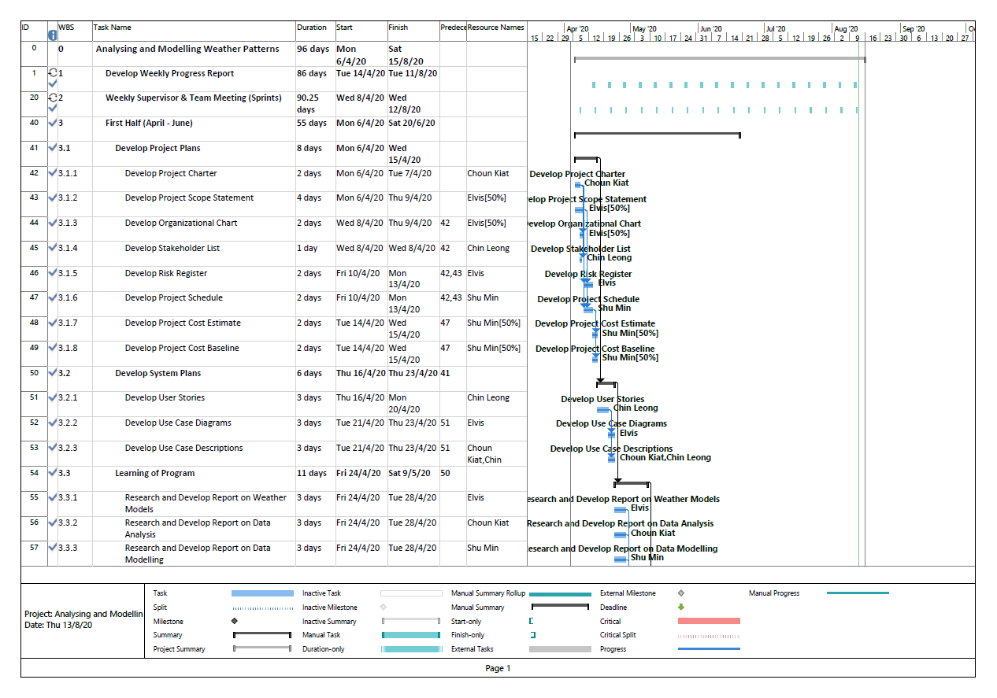

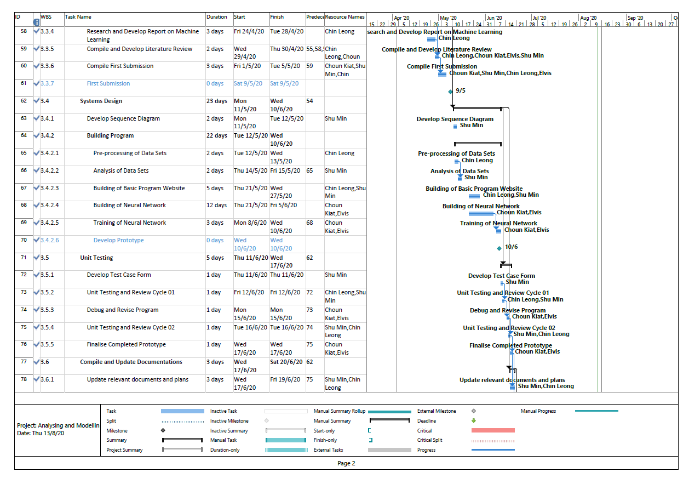

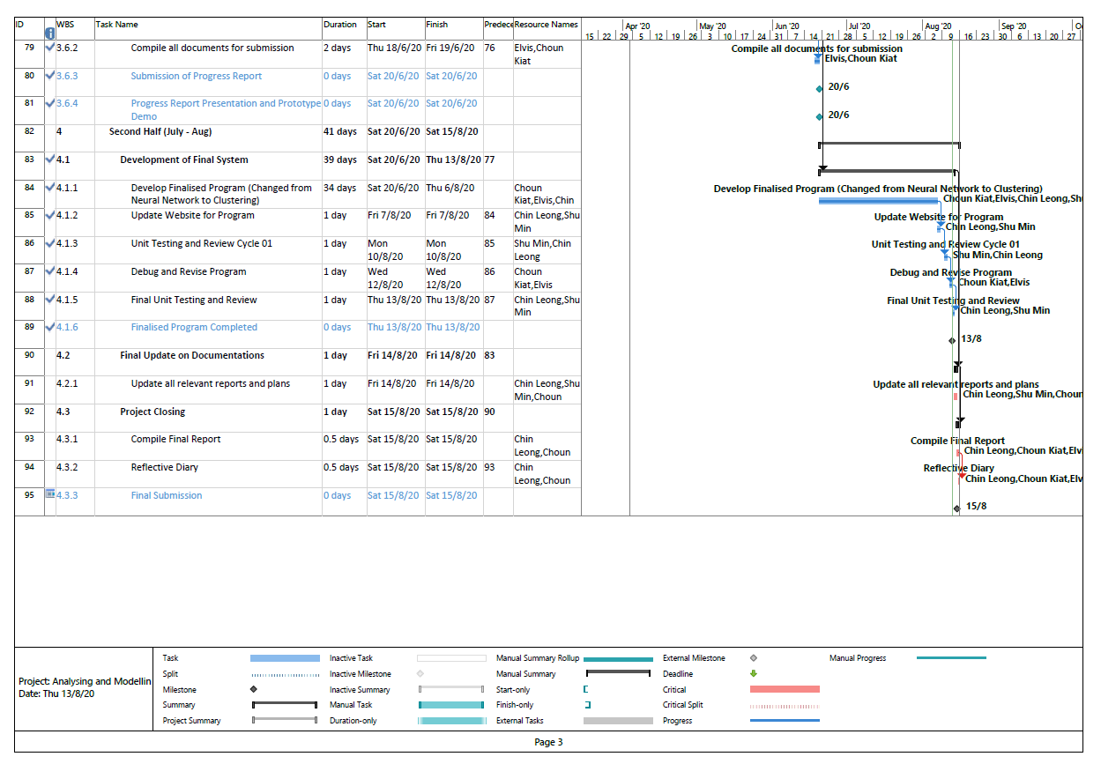

# User Manual

## *Introduction:*

This user manual has been created with the intention to provide assistance to users who wish to use the Weather Modelling System. The comprehensive manual contains all essential information which would allow the user to fully utilise the system. Notably, it includes a description of the system functions and capabilities, contingencies and alternate modes of operation, and step-by-step procedures for system access and use. Please refer to the screenshots provided below in the manual as it would be advisable to have some knowledge of analytics in order to understand some of the complex charts, however, explanations are provided to assist users to understand the charts.

To start the program, unzip everything in weatherModel.zip, open weatherModel file, open the server R file and click on run app

## *For User:*

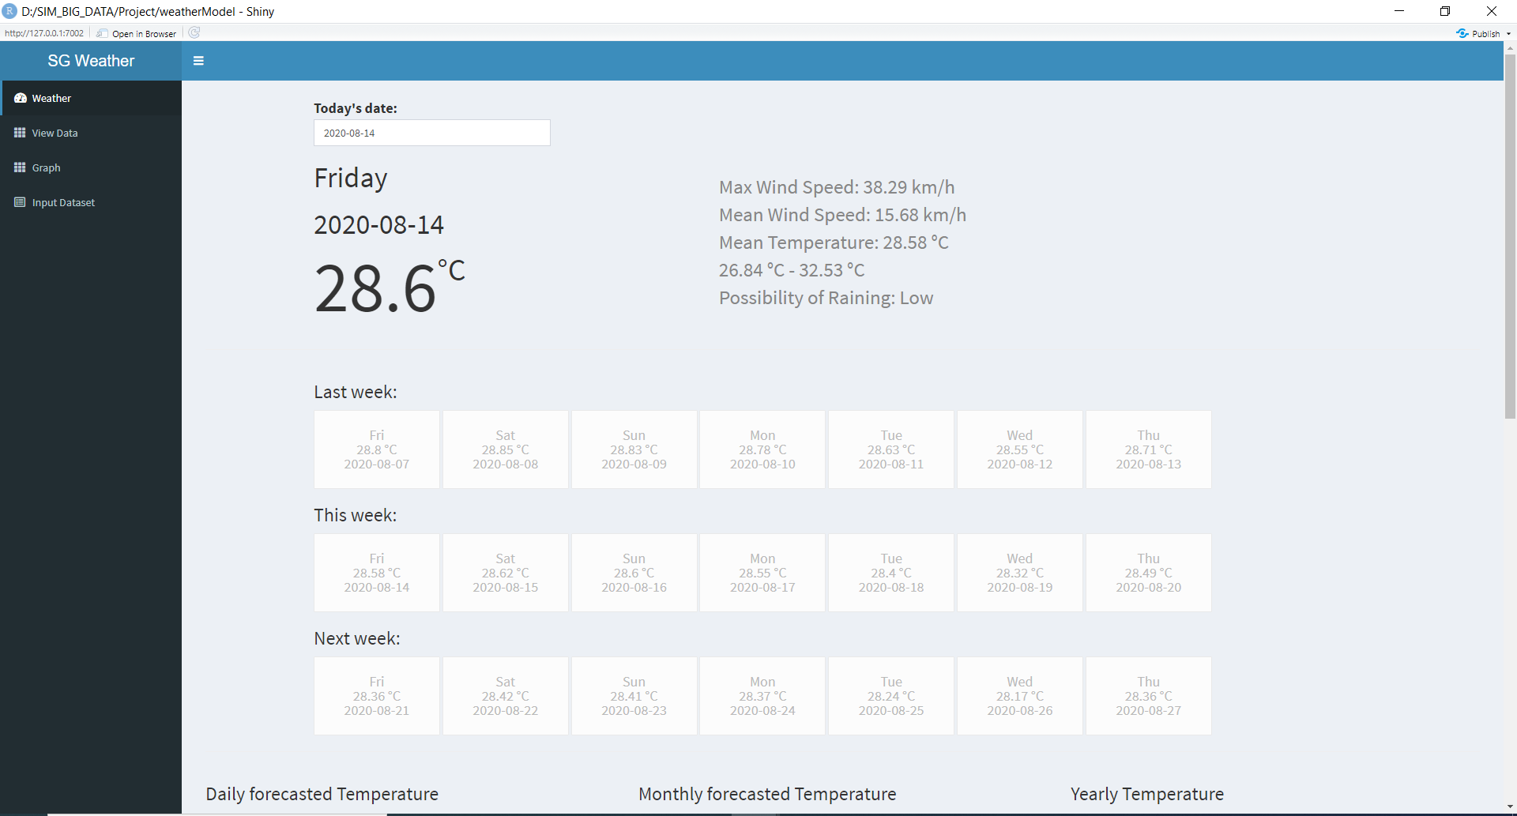

1. When the website loads, the user will be directed to the first tab of the website.
2. The website displays today’s date and weather forecast (mean temperature, min temperature, max temperature, mean wind speed, max wind speed) for previous, current and next week
3. User selects date that he/she wants to view the forecast by clicking on the date
4. User clicks the **Weather** tab to be redirected back to the Weather page which is the current page.

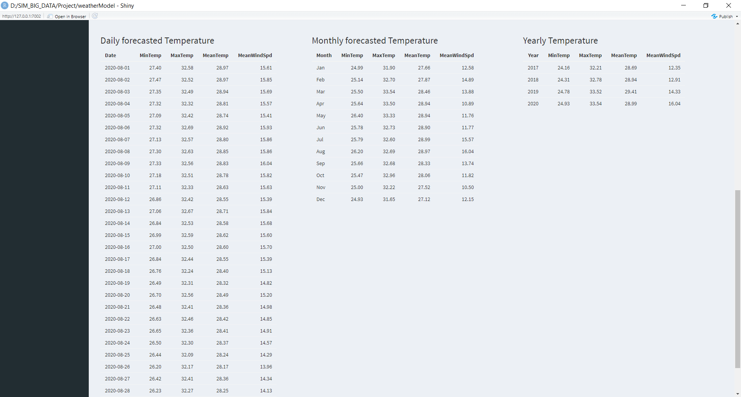

1. User scrolls down to view more information on forecasted data in table format.
2. Information on forecasted data included:

* Daily Forecasted Temperature for current month where it displays the min, max, highest mean temperature, highest mean wind speed of each day of the month
* Monthly Forecasted Temperature for current year where it displays the min, max, highest mean temperature, highest mean wind speed of each month of the year
* Yearly Forecasted Temperature where it displays the forecasted data which trained by our model (prophet model) for each year

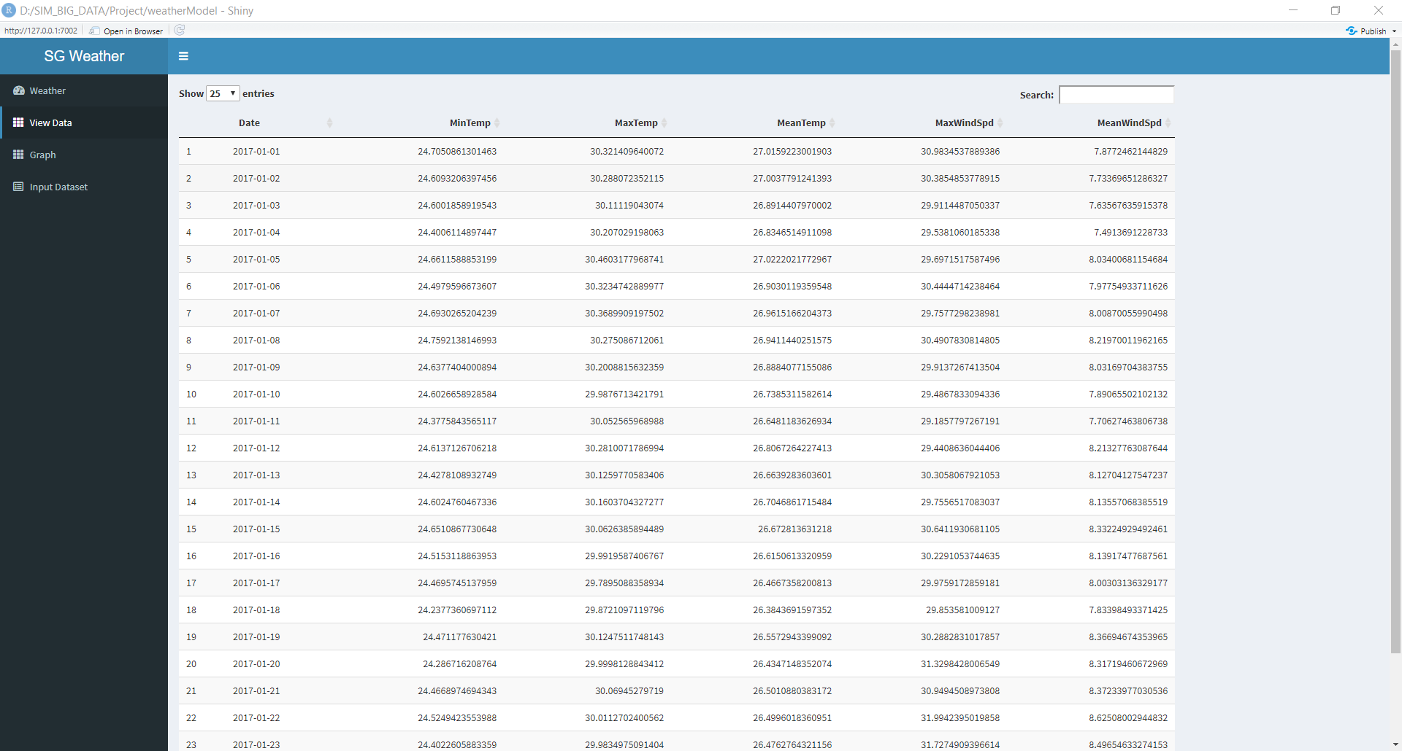

1. User clicks **View Data** tab to be redirected to View Data page.
2. By default, all the forecasted data that we trained will be displayed on this page.
3. User ables to find out the forecasted temperature and wind speed by typing the specific date that he/she wants to find out in the search textbox.
4. User is able to choose how many data entries he/she wishes to view.



1. User clicks **Graph** tab to be redirected to Graph page.
2. By default, the year 2019 will be selected on the slider and the graph will show 2019’s data.
3. The range of year in the slider will be retrieved from the database so it will depend on how many years of data that is in the database.
4. Users can view past year graphs to find out the trends/pattern of past year temperature and wind speed.
5. User selects the year that he/she wants to view the graph on by sliding to the year on the year slider.
6. Users are able to view the graph for Mean Temperature, Mean Wind Speed, Min Temperature and Max Temperature of the selected year.

## *For Meteorologists:*

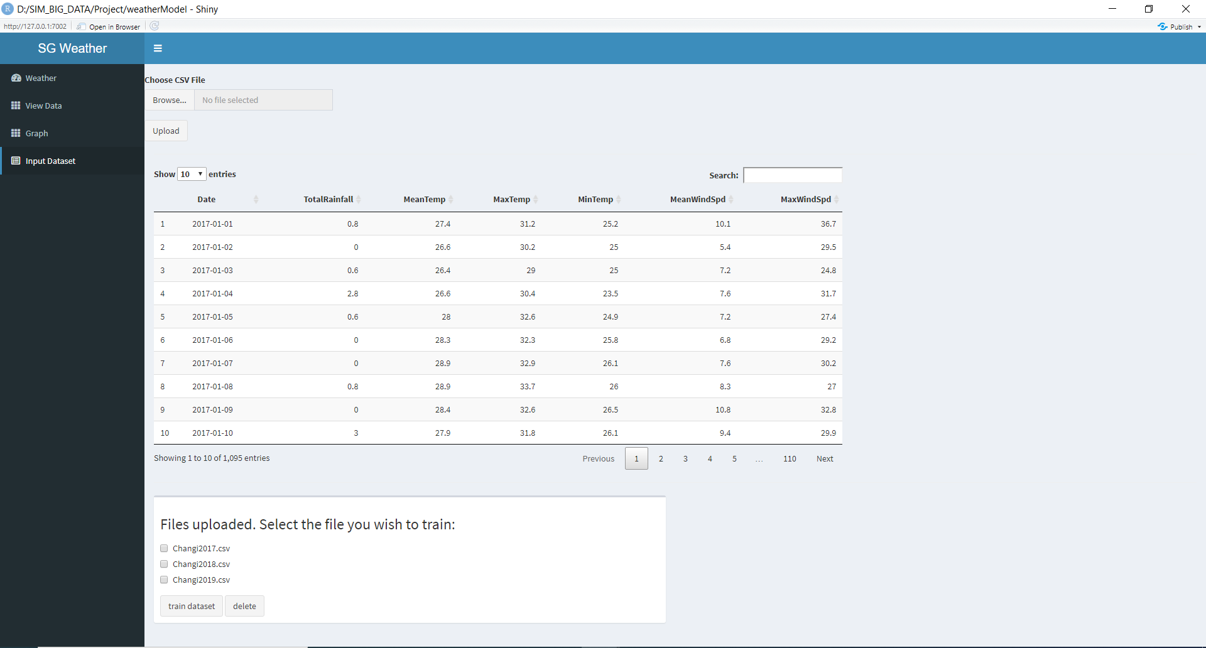

1. Meteorologist clicks on the Input **Dataset** tab to be redirected to the Input Dataset page.
2. Meteorologist clicks the browse button to select the dataset (in .csv file format) that he/she wishes to save in the database.
3. Only files that are in csv format are allowed.
4. Meteorologist clicks the upload button once he/she has finished selecting the dataset.
5. After clicking the upload button, the dataset will be saved to the database and display in the data table.
6. Meteorologists are able to view the datasets that are saved in the database in the data table.
7. Meteorologists are able to search specific data by typing in the search text box.
8. Meteorologists can select the number of entries to view at once.
9. Meteorologists can choose the dataset to train to forecast the weather by checking the dataset in the checkbox.
10. Meteorologist clicks the **train dataset** button once he/she has finished checking the checkbox and the system will start to train the model.
11. The year 2019 dataset must be selected to forecast year 2020 weather(temperature, wind speed)
12. Minimum of 3 datasets must be selected to ensure better accuracy of the model.

# Meeting Minutes

